Good News Feedback
Mid-Test Matters
Issue 29 01 December 2021
A newsletter from the Borough Councillors of the Mid-Test Ward
As we move around the Mid Test parishes, we find many excellent initiatives and projects being undertaken by individuals and organisations. Often these never get the recognition they deserve, and other parishes don’t get to learn from each other.
Do you have a good news story you want to share in our Newsletter so we can give you the recognition and let others learn from your success – just let us know

Recycling over Christmas and New Year 2021/22
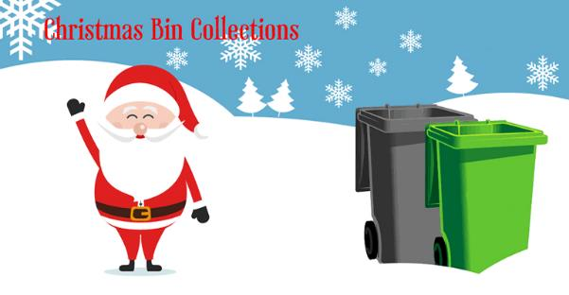
Christmas trees - Once the festive season is over, you can recycle your real Christmas tree at one of the 9 temporary sites provided. The ones closest to Mid Test Ward are below but the full list is on the TVBC web site.
- Dobbies Garden Centre Salisbury Road
- Alma Road Car Park (near Waitrose) Romsey
- Village Hall, West Wellow
- Hillier Garden Centre Braishfield
Please remove all decorations and non-compostable items before recycling.
These sites are provided for real Christmas trees only from Thursday 30 December to Monday 10 January. If you subscribe to the Garden Waste Collection Service, we can collect your Christmas tree (please only cut it in half if it’s over 6ft).

Waste and Recycling Bin Collections
Black bins will be collected on the normal days, but brown bins collection days are:
Normal Collection Day Revised Collection Day
Monday 3 January Tuesday 4 January 2022
Tuesday 4 January Wednesday 5 January
Wednesday 5 January Thursday 6 January
Thursday 6 January Friday 7 January
Friday 7 January Saturday 8 January
Garden waste collections - will not take place between Monday 20 December and Friday 31 December. Collections will be a day later during the week commencing 3 January.
Excess Waste - During the Christmas and New Year period only waste left in bags beside the black bin on a household waste collection day will be accepted. Collection teams will only empty one black bin per property unless extra bin capacity has been authorised.
Excess Recyclables - Recyclable materials in cardboard boxes left beside the brown bin on recycling weeks will be collected throughout the year.
Gift Wrapping Paper -- Do not put gift wrap in the brown recycling bin. Most gift wrap in plastic film, foil, or heavily over-printed, low-grade paper. Used gift wrap is also often scrunched up and covered with sticky tape. Overall, it has very little material benefit for recycling.
Household Waste Recycling Centres - These will be open except on Christmas Day, Boxing Day and New Year’s Day
Any questions about recycling or any other TVBC questions contact us.


GP Services
Healthwatch Hampshire have just launched a survey asking the public to share their experiences of accessing GP (General Practice) services in the last 6 months in Hampshire. They want to hear as many experiences of accessing GP services as possible, so we can help the NHS understand what is working well and what could be better. The results of this survey will be shared with NHS Services and organisations to help to shape the way services are delivered in the future.
You can read more about the survey and the wider project here and the survey is here survey

Christmas Lights
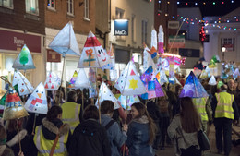


Christmas in Romsey
Christmas lights switch on! Got your eye
on some late-night shopping?
December 10 is the date for your diary!

Click here for the full list

Stockbridge festive cheer!
Stockbridge High Street will be lit up for all to see on December 4 this year!
Mulled wine, mince pies and more will be available to accompany the live brass music and choir singing ahead of the switch-on at 6pm.
See the details

Explore Test Valley

Discover the beauty of Test Valley with our walking routes. Enjoy some time alone or with friends and family while taking in nature this autumn and winter. It certainly makes a great day out when combined with a hearty, well deserved pub lunch!

View walks in Test Valley

StreetSafe
The government is trialling a new online tool until the end of November which lets members of the public anonymously pinpoint on a map a location where they don’t feel safe.
StreetSafe has been introduced as part of the government’s response to tackling violence against women and girls (VAWG), but it should also be used to identify areas where there are fears caused by other things such as anti-social behaviour, and environmental issues.
Anyone who has concerns about a particular location is encouraged to flag it through the tool. This information will be considered alongside the extensive evidence base already gathered by police forces and used to inform the community safety activities of police and partner agencies.
https://www.police.uk/pu/notices/streetsafe/street-safe/

Green Flag Awards

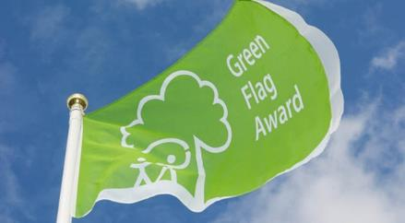

Romsey’s War Memorial Park, Rooksbury Mill in Andover and Valley Park have all been awarded a coveted national prize of a Green Flag Award.
More so than ever before, green spaces in the borough have been significant to residents and visitors. Lockdown gave an opportunity for communities to prioritise spending time outdoors in the fresh air, with many exploring new spaces and even discovering the beauty of Test Valley for the first time.
Green spaces in Test Valley have provided the space to breathe and reset during challenging times and, never more than this year have they deserved to be acknowledged for their management.
See our parks and green spaces

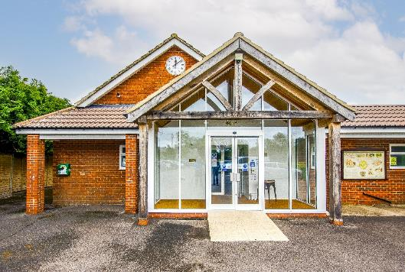
Covid-19 guidance for community halls and centres

The Action Hampshire website have some useful resources for Village Halls and meetings in general during Covid: Opening your community building after lockdown - Action Hampshire. There’s also a piece there on face coverings becoming compulsory again from the 30^{th of} November.

ACRE also have an article on keeping village halls safe this winter, although this is slightly old but perhaps still useful Advice for keeping village halls safe this winter - ACRE | Action with Communities in Rural England



The council has launched a brand-new email update system this week. The system allows regular useful information to be sent out to those who choose to subscribe and can be personalised as users select their preferences for what they'd like to hear about.
Events, Christmas bin collection dates and countryside information are just some of the updates being sent out. Users of My Council Services will this week have had a one-time email to notify them of this new service, asking them if they would like to subscribe. Their details are not being stored on the system and they have to opt-in to receive these new updates and can unsubscribe at any time.

Springing up

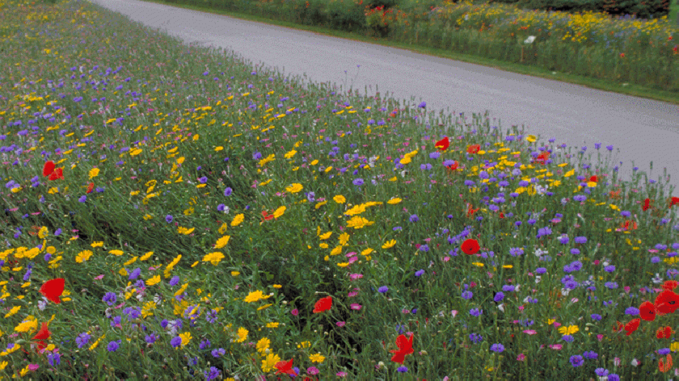

Urban meadows are springing up across the borough and look set to grow in numbers after a successful first year trialling the project by Test Valley Borough Council.

In spring, a change to the frequency of mowing grass was made across seven hectares of green space to encourage the growth of wildflowers and plants. Now, over the next two years, this is set to grow to 18 hectares.

Christmas & New Year Wishes

We would like to take this opportunity to wish all the residents, volunteers, community organisations and Parish Councils in Mid Test a Merry Christmas and a Happy New Year

Councillor Ian Jeffrey cllrijeffrey@testvalley.gov.uk 01794 388872
Councillor Alison Johnston cllrajohnston@testvalley.gov.uk 01794 500610
Councillor Tony Ward cllrtward@testvalley.gov.uk 01794 389649

