Mid-Test Matters
Issue 16 3rd October 2020
A newsletter for Parish Councils from the Borough Councillors of the Mid-Test Ward

New era for Andover as masterplan published

Following our news about Romsey last month now its Andover’s turn for a glimpse into the future. Residents can now take a glimpse into Andover’s future as Test Valley Borough Council has today published its long-awaited town centre masterplan, marking the start of an exciting new era for the town.
The ambitious plans were approved at full council on September 28 and will see the total transformation of the town centre. New routes and improvements to the lanes will see the High Street much better connected to the surrounding area and more welcoming for independent retailers. Town centre living will also play a key role, new accommodation at upper floors will create ready-made footfall for shops and eateries, bringing life in the evenings and helping to fund the wider redevelopment plans.
One of the most radical changes would see the existing Chantry Centre site replaced with mixed use development, delivering space for more independent retailers, health, community and leisure uses, space for pop-up retailing, as well as new office space and apartments at upper levels. A new The Lights theatre would be the star attraction overlooking a bustling new square where people could relax and dine, bringing a more social feel to the picturesque Georgian market town.
A stunning riverside walk will showcase Andover’s largely hidden watercourse, the River Anton, offering the perfect setting for families and friends to picnic and wander along the water’s edge.
The plans also recommend the development of a spectacular Wellbeing Quarter, which will encompass the area around Andover Leisure Centre and include a new college campus, creating a modern space for people to exercise, relax and enjoy. This would also help to create a green corridor linking the River Anton to Vigo Park and open up stunning views to St Mary’s Church at the heart of it.
The proposals, which have been 12 months in the making, are the work of nationally renowned designers, HemingwayDesign and NEW Masterplanning. They have consulted with more than 4,000 residents, businesses and other stakeholders to form an innovative new vision for the town.

Andover masterplan river green space corridor
The masterplan and flythroughs, which enable viewers to step into the future and take a look around the new town centre, are available at www.thinkandovertowncentre.co.uk
Now the council has approved the plans the authority will press ahead with appointing a developer partner to begin work on delivering the major changes in the town centre, with the masterplan acting as a blueprint.
Andover masterplan entertainment area
With the scale of the redevelopment, the council expects the work to be carried out in phases and will help to relocate any businesses displaced during the work to alternative town centre premises.

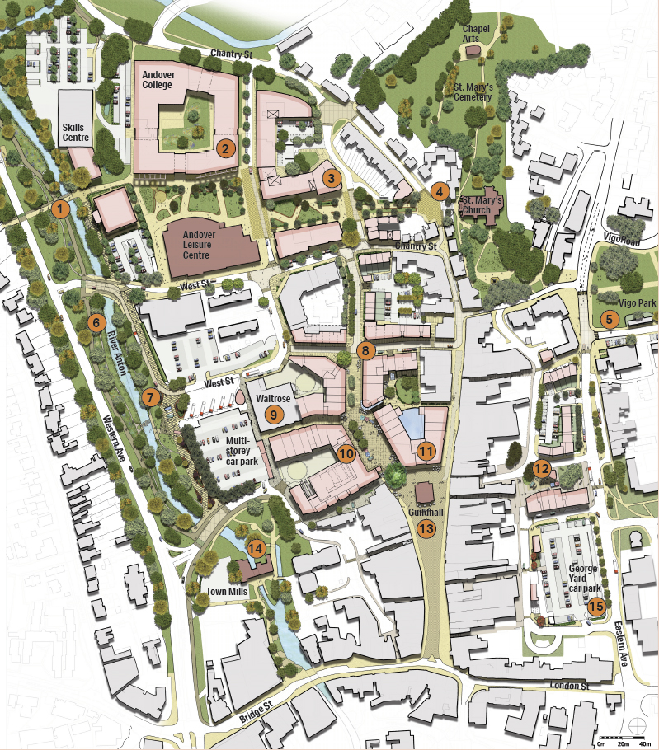
Map of the development area for Andover

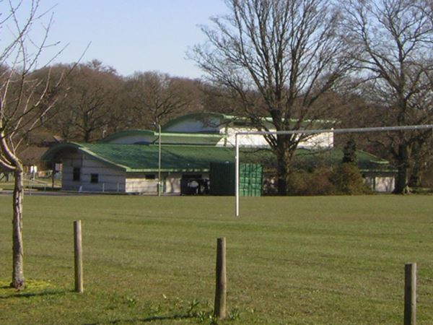
Fly-tipping update
We may not have been able to update you regarding any prosecution updates recently, but we have been working hard ‘behind the scenes’ with our colleagues in Legal Services, as fly tipping has continued through the lockdown and beyond.
We currently have 16 cases with the courts – many booked during the lockdown. Furthermore, we have 9 cases pending prosecution and 37 live cases, currently being investigated. We look forward to sharing with you all our court success stories shortly
A message from the safeguarding partnership at Hampshire County Council
The Hampshire Safeguarding Adults Board is pleased to announce the launch of the Let’s Plan Ahead (LPA) Campaign, a multi-agency initiative which aims to raise awareness and drive the uptake of Lasting Power of Attorney for Health and Welfare.
The HSAB website is hosting the campaign on new, dedicated webpages found here: https://www.hampshiresab.org.uk/lasting-power-of-attorney/
These pages are intended to provide a range of resources to support both the public and professionals to understand the legal arrangements around making a Lasting Power of Attorney, and to share this information with their family members, within staff teams and within the wider community. There are specific resources related to making a Lasting Power of Attorney for Health and Welfare as the uptake of these is low nationally and every adult should consider having this in place regardless of their age. The resources include short films and information documents which can be downloaded and printed.
Council teams up to launch faster new booking system
Test Valley Borough Council has teamed up with Pitchbooking to launch a new, easy, automated booking system for the council’s sports pitches.
Previously, residents and sports clubs across the borough who wanted to use the pitches, would have to ring through and manually book. Now, the system, which launches on September 14, will allow a completely online service which will run 24 hours a day.
Those hiring the pitches can select which location they wish to book, select a time and have the option of a recurring booking, and pay. The new system is also easy to use on mobiles and tablets, as well as PCs.
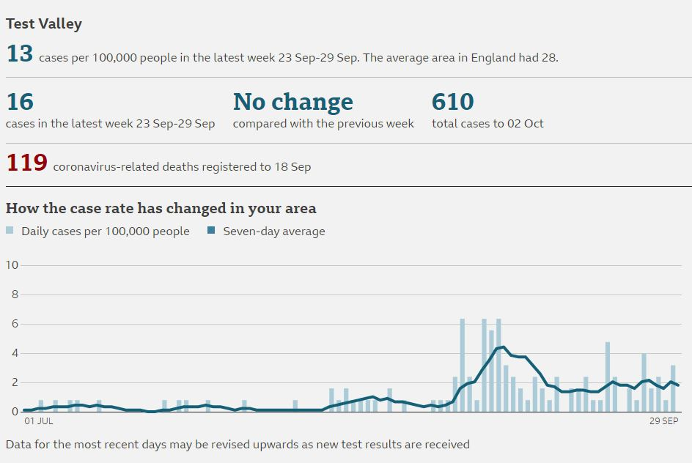
Latest Test Valley Covid-19 Data

New strategy launched for green spaces
Test Valley Borough Council is calling on residents to have their say to help protect and enhance green spaces across the borough for the next ten years.
The council has launched a consultation for the next four weeks, on its Draft Green Space Strategy. The document covers the issues that are facing green space, and looks at how to resolve them to ensure safe, enjoyable and accessible spaces for years to come.
Now, the authority is calling on residents to have their say on how the council can best deal with these issues, including managing diverse spaces with a range of wildlife, in the face of a warming climate.

Residents can have their say before October 23 by emailing greenspacestrategy@testvalley.gov.uk.

Staying in Contact
We continue to have meetings via telephone or video conferencing where we can and we are all adapting to these new ways of working. If you need to speak to Borough councillors outside of these meetings, our contact details are below

Our Contact Details
Councillor Ian Jeffrey cllrijeffrey@testvalley.gov.uk 01794 388872
Councillor Alison Johnston cllrajohnston@testvalley.gov.uk 01794 500610
Councillor Tony Ward cllrtward@testvalley.gov.uk 01794 389649

