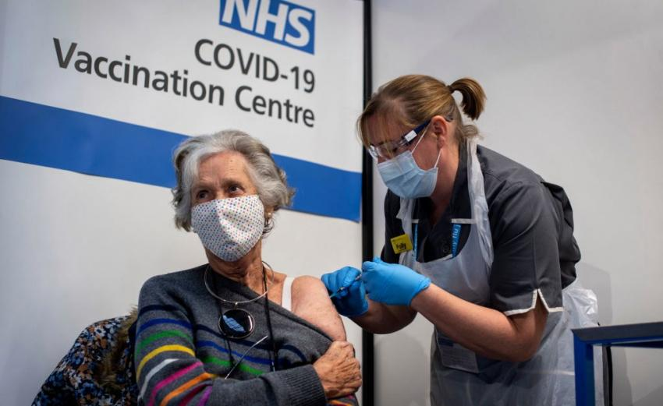
Mid-Test Matters
Issue 20 01 February 2021
A newsletter from the Borough Councillors of the Mid-Test Ward

The Vaccine Miracle
In less than a year since Covid-19 first appeared in the world scientists have developed vaccines that give hope that the virus might be defeated – surely one of the most outstanding scientific achievements of all time. Three vaccines are approved here in the UK with two more awaiting approval. The first UK vaccination was 8th December and already nearly nine million people have received the first dose of a vaccine, with about 490,000 having received two jabs. Across Mid Test a number of sites are being used primarily by GP practices to roll out the vaccine to the most vulnerable groups. The Council has provided Crossfield Hall in Romsey and The Lights Theatre in Andover as centres. All the centres are being supported by an army of volunteers helping in a number of ways. Its yet another reminder of the value of volunteering and Test Valley Borough Council has been working with Unity throughout the pandemic not only to provide support but also encourage and recruit volunteers. Imagine if we could maintain that enthusiasm for volunteering once the pandemic is over.

Helping vulnerable people to get their vaccinations is one of three pledges the government has asked the public to make to support the largest vaccination programme in British history.
The 3 pledges are:
- Help out - help those aged 80 and over by supporting friends, family and loved ones with their appointments, as well as volunteering to help those in the community
- Join up - sign up to clinical trials for COVID-19 vaccines and treatments
- Stay informed - keep up to date with accurate and trusted NHS advice and make sure to share facts with friends and family
By taking part in one or more of these pledges, members of the public can join the national effort and support the NHS as the vaccination programme continues to expand. https://www.gov.uk/government/news/british-public-urged-to-play-their-part-in-historic-vaccine-roll-out
We cannot over emphasise how important it is that everyone that can has the vaccine for their own protection but so that we can all as soon as possible return to living in a more normal way
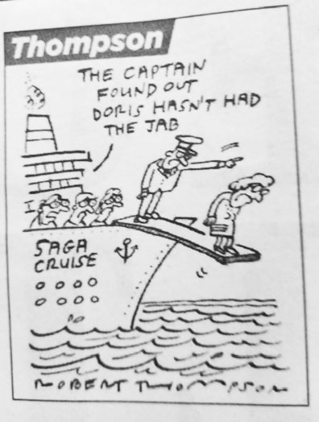

Unity Community Transport – including for medical appointments & vaccinations
The fares are set out below:
£5 Full Fare or £3.75 with bus pass for Test Valley Area
£3 Full Fare or £2.25 with bus pass central Romsey
Out of area transport is being charged at £0.30ppm from Test Valley border and normal fare for portion within the area
Unity can be contacted on the following: transport@unityonline.org.uk
01264 356808-Unity Transport
To be eligible to use transport normally residents would have to fulfil certain criteria such as living more than 400mtrs from a bus stop and/or have a disability or be unable to use public transport for other reasons – to be fair they are quite broad criteria. They also need to register with us to be able to travel, registration is free, and Unity can do it at the same time we pick them up if time between booking and travel is short.
Unity is able to take people to medical appointments and vaccinations even if they are outside of the Test Valley area, which is happening quite a bit at the moment with passengers traveling to Winchester etc for treatment.
However, even in the midst of this good news there are fraudsters out there.
The NHS will:
NEVER ask for payment - the vaccine is free.
NEVER ask for your bank details.
NEVER arrive unannounced at your home to administer the vaccine.
NEVER ask you to prove your identity by sending copies of personal documents such as your passport.
Forward suspicious emails to: report@phishing.gov.uk and any suspicious text messages to 7726 which is free of charge.
On this poster are the top 4 methods that are being used by fraudsters that are also listed above. The poster can be used to raise awareness and provide advice.
Vaccine FAQs
Finally, on vaccines we have included the latest Hampshire and Isle of Wight vaccine stakeholders briefing which has a wealth of information.

Businesses urged to apply for Covid-19 grants
Test Valley Borough Council is urging all local businesses impacted by the pandemic to apply for the coronavirus support grants.
The government is expected to provide further financial assistance after it was announced on 23 December that Test Valley would be plunged into tier 4 from Boxing Day following an increase in Covid-19 cases across Hampshire and the South East. But there are already hundreds of thousands of pounds available for those affected by the previous lockdowns and tier 2 restrictions.
There are currently five live schemes, with grants varying from between a few hundred pounds to £3,000 for every 28-day period. They include money for those businesses that have been forced to close as a result of the national restrictions, as well as those that remained open but whose custom was significantly impacted. There is also a one-off Christmas support payment of £1,000 available to all wet-led pubs.
To view the full list of grants available and to apply, visit www.testvalley.gov.uk/businessgrant

Parish Council Survey on Sustainability and Climate Change
The Council’s Climate Emergency Action Plan recognises our role in supporting communities to take action on climate change and wider sustainability issues. In this context, and following discussion at last year’s Test Valley Association of Town and Parish Councils / TVBC conference, we are about to send out a short survey to help us understand more about the projects and initiatives that are already underway within communities. It is intended that the responses we receive can help shape the next steps we take together and enable us to share best practice between local communities.
The request to complete the survey will be sent to Parish Councils this week, with the request for it to be completed by 5 March.
In case of interest, the survey is available at: Sustainability and Climate Change Activity Survey

Glass Recycling Update
We now have glass recycling facilities located at Longstock Park Nursery, near Stockbridge (SO20 6EH). Residents will now be able to recycle their empty glass bottles and jars when they next visit!
We are grateful to the nursery for their support in providing a site in a much-needed location
Flooding
It seems unbelievable that in the middle of a pandemic we should have to worry about another possible crisis but many areas in the country have already had to suffer flooding. So far Test valley has not had to contend with this. Most Parish Councils have Resilience Plans covering flooding and are prepared to swing into action with all the relevant authorities. The Environment Agency monitor our river and ground water levels to provide early warning of any flooding risk. The best way for the public to be prepared is to sign up to the warnings.
Check if you are at risk of flooding by signing up to receive free flood warnings by phone, email or text message by visiting www.gov.uk/flood or calling Floodline 24-hours on 0345 988 1188.
You can check groundwater status in your locality at https://sites.google.com/view/groundwatergraphs
Other sources of information are: -
www.flood-warning-information.service.gov.uk
Test Valley Borough Council
Parish Council Flood Groups
www.nationalfoodforum.org.uk

Our Contact Details
Councillor Ian Jeffrey cllrijeffrey@testvalley.gov.uk 01794 388872
Councillor Alison Johnston cllrajohnston@testvalley.gov.uk 01794 500610
Councillor Tony Ward cllrtward@testvalley.gov.uk 01794 389649

