Mid-Test Matters
Issue 24 02 June 2021
A newsletter from the Borough Councillors of the Mid-Test Ward
Coronavirus update
The impact has been enormous as there have been almost 4.5 million confirmed cases of coronavirus in the UK and nearly 128,000 people have died. Millions of people have sacrificed so much with the physical and mental costs of the lockdowns but that effort and the miracle of science is paying off. More than 39 million people in the UK have now had their first dose of a coronavirus vaccine and no deaths were announced in the UK on Tuesday for the first time since the pandemic began in March 2020. Its not over yet and we must remain vigilant to the basics of Hands, Face, Space and Fresh Air. It seems we are in a race between the mutating virus and our ability to get everyone vaccinated. In Test Valley the number of cases is 13 per 100,000 people compared with an average of 16 for the whole of the UK. Like the rest of the UK there is now a slight rise in the case rate as restrictions are eased. The Borough figures show 76% of adults have received one jab and 49% two vaccinations.
Vaccine study
University Hospital Southampton NHS Foundation Trust has confirmed that a new clinical trial looking at different Covid-19 ‘booster’ vaccines has launched. The Cov-Boost study, backed by £19.3 million of government funding through the Vaccines Taskforce, will run at University Hospital Southampton, University Hospitals Dorset and the Portsmouth Research Hub (Portsmouth Hospitals), and is being led by University Hospital Southampton. It will be the first in the world to provide vital data on the impact of a third dose on patients’ immune responses.
The study is recruiting participants through the NHS COVID-19 Vaccine Research Registry, with vaccinations anticipated to start from the beginning of June. The initial findings, expected in September, will help inform decisions by the Joint Committee on Vaccination and Immunisation (JCVI) on any potential booster programme from autumn this year, ensuring the country’s most vulnerable are given the strongest possible protection over the winter period.
Pharmacies sites offering lateral flow tests and collections
Below is a link to the map and list of pharmacies offering collect, and testing, options in the Hampshire County Council area.
Where to collect lateral flow test kits: Find where to get rapid lateral flow tests - NHS (test-and-trace.nhs.uk
List of all sites offering pharmacy test (all sites offering pharmacy test, also offer pharmacy collect): COVID-19: In-pharmacy testing and test kit collection | Health and social care | Hampshire County Council (hants.gov.uk

Most vulnerable offered second dose of COVID-19 vaccine earlier to help protect against variants
The country’s most vulnerable are to be offered their second COVID-19 vaccine earlier, the government has announced, as part of plans to tackle rising cases of the B1.617.2 variant of concern first identified in India.
Appointments for a second dose of a vaccine will be brought forward from 12 to 8 weeks for the remaining people in the top 9 priority groups who have yet to receive their second dose. This is to ensure people across the UK have the strongest possible protection from the virus at an earlier opportunity.
Announcement: https://www.gov.uk/government/news/most-vulnerable-offered-second-dose-of-covid-19-vaccine-earlier-to-help-protect-against-variants

Importance of Fresh Air
Public reminded to let in fresh air when meeting others indoors to reduce the spread of COVID-19
Everyone across England is being encouraged to remember, ‘when you let friends in, let fresh air in too’ in a new government advertising campaign. The public information campaign has launched on the same day groups of 6 people, or 2 households, will once again be able to meet indoors, and indoor hospitality, leisure and entertainment industries are reopening their doors. As more people begin to spend time with friends and family inside, the campaign continues to highlight the importance of letting in fresh air. Fresh air helps disperse infected COVID-19 droplets in the air that may carry the virus, helping prevent the spread of the disease. The public are being encouraged to open windows when socialising at home and businesses are asked to ensure adequate ventilation at indoor venues.
Announcement: https://www.gov.uk/government/news/public-reminded-to-let-in-fresh-air-when-meeting-others-indoors-to-reduce-the-spread-of-covid-19

The Importance of Covid-19 Volunteer Groups
Over the last 16 months many groups have been formed in the community by concerned individuals who want to help others in need. Often, they have faced barriers and issues that have prevented them working as effectively as they could. My research has shown that where the authorities work with volunteer groups the combination of effort maximises the benefits those in need.
The Winston Churchill Memorial Trust is conducting a short survey to explore the work of the groups and you could all help with your knowledge and experience by filling in the questionnaire which you can find here. https://www.surveymonkey.co.uk/r/9F57DN3

Other Borough News
The Worshipful the Mayor, Councillor Mark Cooper
At the Annual Council meeting on 19 May 2021, held in the Romsey Theatre, Councillor Mark Cooper was elected as the new Mayor for the Borough.
The Test Valley Mayor is a Borough Councillor, and is elected to the post by fellow councillors at the Council's annual meeting in May each year.
In addition to being the Borough's 'First Citizen', the Mayor chairs meetings of the whole Council, and acts as the Council's public figurehead. Mayors are expected to remain politically impartial, particularly when chairing Council meetings (calling speakers to take part in debates and ruling on procedural matters). The political leadership of the Borough Council is the responsibility of the Leader of the Council, a separate elected post.
As first citizen of Test Valley, the Mayor receives royalty, dignitaries and other visitors to the Borough, opens and attends conferences and numerous events, large and small, and represents the Council at civic functions.
The Mayor may be contacted through his office.
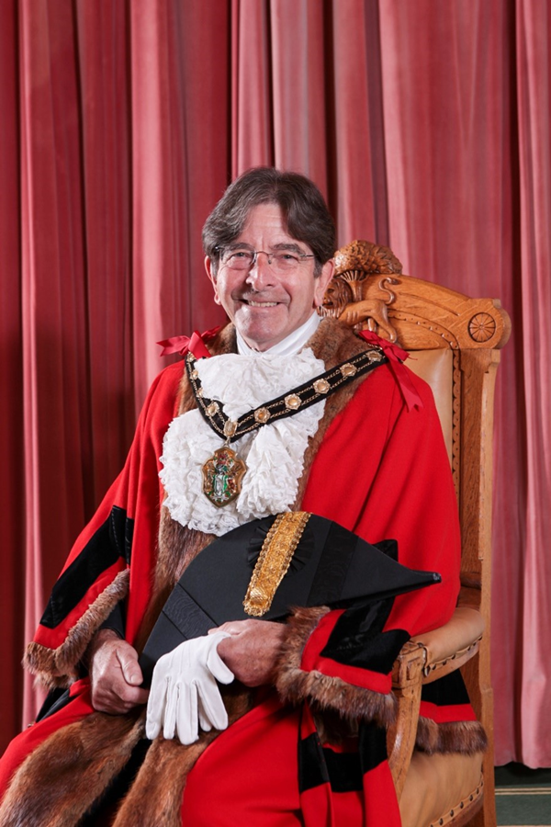
The Deputy Mayor for 2021/22 is Cllr Alan Dowden and Deputy Mayoress Cllr Celia Dowden

Parish Council Sustainability and Climate Change Event
TVBC will be hosting a virtual climate change event for parish councils at 7pm on Tuesday 22nd June.
A survey of parish councils earlier in the year helped to identify the great work going on in the parishes and the topics they were most keen to hear more about. In response to those priorities, the event will feature talks from the ‘Greener Villages’ group which has been set up jointly between Wherwell and Chilbolton Parish Councils, the Hampshire and Isle of Wight Wildlife Trust, the Woodland Trust and the Council’s Countryside Team.
Housing Development Team launches new in-house rural affordable housing needs survey
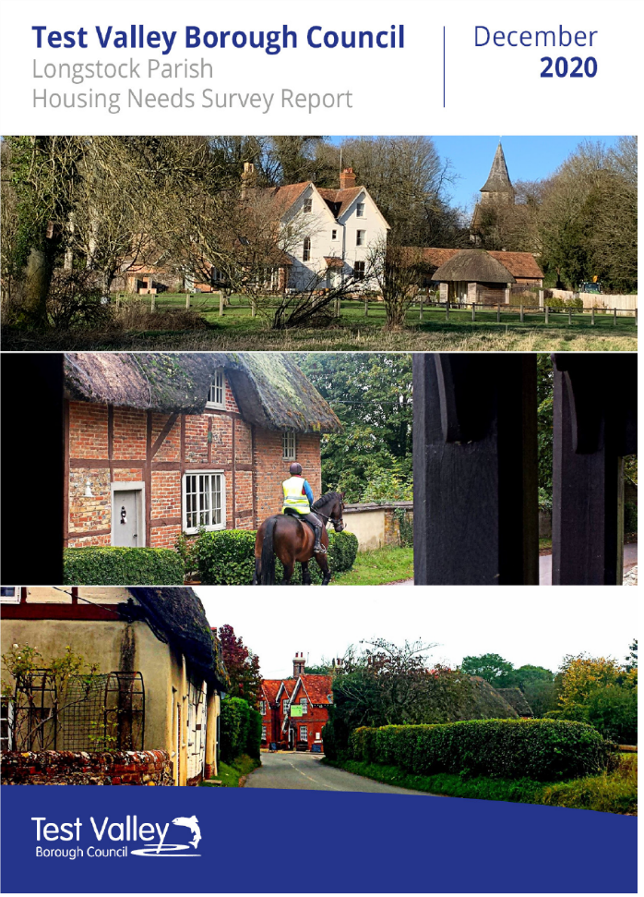

The Housing Development Team has recently launched its new in-house affordable housing needs survey which is available to use in rural parishes across the borough. The new survey will play an important part in establishing the affordable housing needs in a parish, and will also enable the Housing Development team to work closer with the parish councils and local communities to help deliver the type of housing that is needed for local residents.
Previously the surveys were commissioned through the Hampshire Homes Hub, with the council paying a fee for each survey completed. This new in-house survey is funded through the same budget, but costs significantly less per survey, enabling more surveys to be completed each year. It also enables the council to have a consistent approach to the content of the surveys, and to have full ownership of the rural enabling service without the involvement of a third party.
The first in-house survey has recently been completed for Longstock Parish Council. Feedback from the Parish Council on the content of the survey report was very positive, and more surveys for other parishes are now in the pipeline. The completed housing needs survey report for Longstock can be found on the Council’s website:-
https://www.testvalley.gov.uk/housingandenvironmentalhealth/housing/housing-development/housing-need-surveys

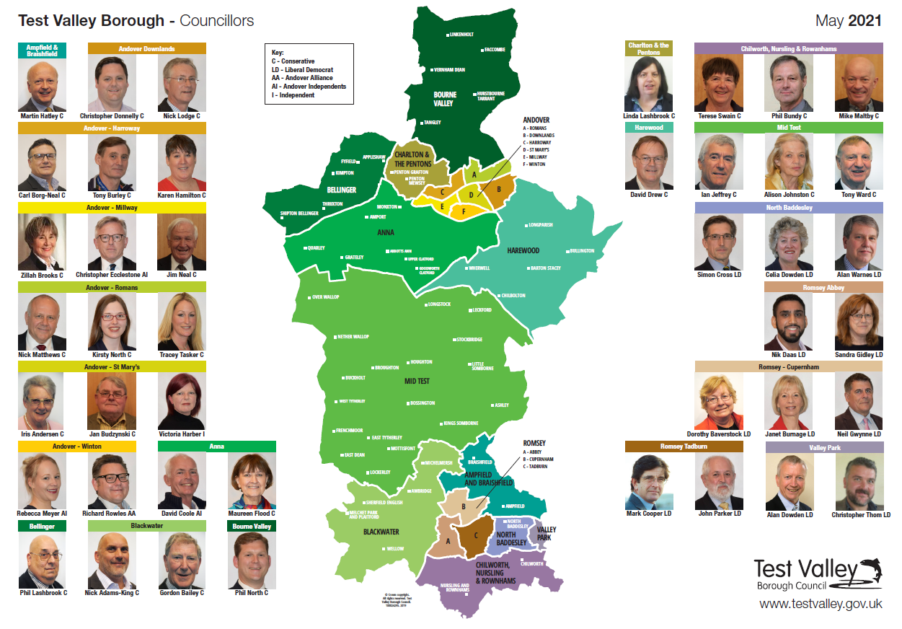
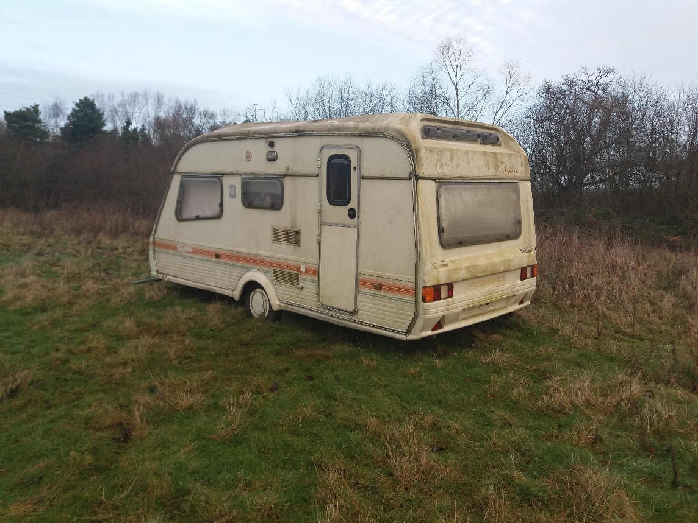
New Test Valley map and councillors updated 2021 - download a copy here

Fine for caravan tipper
A man who dumped a caravan doused in diesel on The Broadlands Estate has been ordered to pay almost £1,500 in court.
He claimed he was doing a friend a favour after removing the caravan from an address in East Wellow. However, instead of disposing of it legally, he dumped it, including the contents which consisted of boxes and bags of furniture, household rubbish and other waste.
While saying that he had previous permission to leave the caravan at the location, an investigation by Test Valley Borough Council begun after The Broadlands Estate contacted the authority having discovered the fly-tip.
The defendant admitted fly-tipping and abandoning a caravan in January last year. At Basingstoke Magistrates Court earlier this month, he was fined £480, ordered to pay £838.50 in costs and a £48 victim surcharge, totalling £1,366.50.
Our Contact Details
Councillor Ian Jeffrey cllrijeffrey@testvalley.gov.uk 01794 388872
Councillor Alison Johnston cllrajohnston@testvalley.gov.uk 01794 500610
Councillor Tony Ward cllrtward@testvalley.gov.uk 01794 389649

