March 2022
Issue 32
Page 1
INSIDE
Eunice causes blackouts
Council funding for charity and voluntary sector
Diary
Council budget
Mid Test Communities in Action
Affordable Housing

Local Plan

Romsey-Southampton cycle lane
Fly-tippers
Ukraine
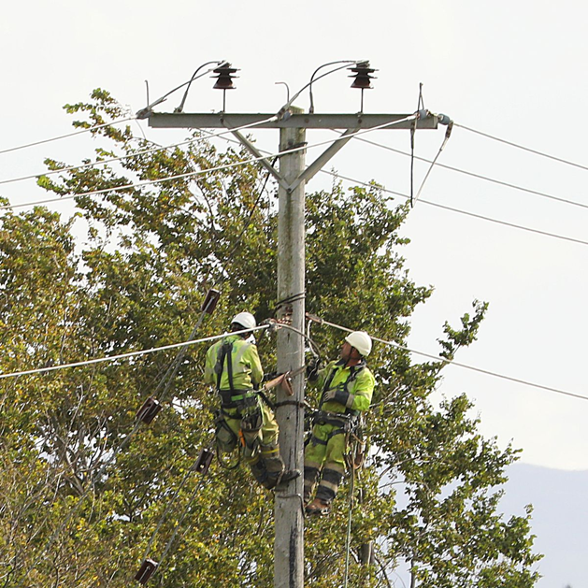
Mid-Test Matters
A newsletter from the Borough Councillors for the Test Valley Borough Ward of Mid-Test
Cllrs Alison Johnston, Ian Jeffrey, and Tony Ward

Eunice causes blackouts
Forecasting of bad weather has improved dramatically and we had a clear early warning of when and where Eunice would arrive and its scale. It caused havoc plunging many homes into darkness without power heat and when the mobile phone network went out no means of communication. This lasted for days not hours and for many of our more vulnerable people was a very difficult time.

Perhaps now would be a good time to look at the Community Resilience Plans and see if they kicked into action or not. Originally developed for floods these Resilience Plans are there for all emergencies including extended power outages. Good questions would be: -
- Have residents been given prior advice on what simple measures they can take to be ready for power outages?
- Does the Community Resilience Plan cover extended power outages?

We would like to hear from you on your experience of this recent event and what needs to change and how we might be able to help.

DIARY | MARCH | 2022
3 Over Wallop PC

7 Longstock PC

8 Community Governance Review Member Panel

8 East Dean PC

14 West Tytherley PC

14 Nether Wallop PC

15 Portfolio Group

15 Southern Area Planning Committee

30 Cabinet

Mid-Test Matters
Page | 1

Council announces £1.2M of funding for charity and voluntary sector

Charities and voluntary organisations are set to benefit from a £1.2M boost over the next three years, after Test Valley Borough Council announced the latest cycle of its Revenue Funding Programme.

A report to the Council’s Cabinet recommended awards ranging from £2,500 to almost £270,000 per year to organisations delivering a range of services, including mental health support, activities for older people, Shopmobility, advice on debt, benefits and housing, youth provision and core support for voluntary groups across the borough.

The report also proposed ring fencing funding for advice services currently provided by Citizen’s Advice Test Valley and for core support to the voluntary sector and Shopmobility, both currently provided by Unity.

Funding for King John’s House will transfer to the council’s tourism function, allowing it to be much better coordinated with other tourism work.

The report recommended that the funding for all the other organisations currently in the programme runs for the next two years, while the Council works with the sector to develop a more accessible funding programme in time for the 2024-25 financial year.

Mid-Test Matters
Page | 2
Council sets out latest budget
Test Valley Borough Council set out its budget plans for 2022/23 at a Cabinet meeting on 23 February, as the authority continues its recovery from the pandemic.
Council chiefs discussed their finance plan for the coming year, which is set in the context of recovering from a budgeted £2.544M shortfall due to the impact of Covid-19 in 2021/22, reduced to £1.050M thanks to government support grants.
The Council had expected its income to return to pre-pandemic levels by the start of 2022/23, which has largely been the case apart from car parking which continues to lag the forecast due to a change in people’s working habits.
While the Council’s Project Enterprise initiative is expected to generate an income of £2.086M, increased costs and uncertainty over funding levels in the medium term mean that the authority is proposing to increase Band D Council Tax by £5 to £153.91 for 2022/23. It also plans to take a modest draw from its reserves to top this up. Despite the proposed increase, TVBC’s share of the Council Tax will remain more than £40 lower than the average for the rest of England.
To protect its most vulnerable residents, the Council recently approved a local Council Tax Support Scheme for low-income households to safeguard them against the full impact of the Council Tax change.
The government also recently announced that households in Council Tax bands A to D will receive a £150 Council Tax discount - around two-thirds of all homes in Test Valley. In addition, the Chancellor has confirmed that local authorities will receive a discretionary fund to help lower income households in higher Council Tax bands.
The below-inflation rise of £5 on a Band D property – less than 10p a week - means an average bill of £153.91 for an entire year of Test Valley Borough Council services. This includes waste collections, maintaining the borough’s parks and open spaces, housing and homelessness, environmental health, managing benefits and grants, planning, licensing, economic development, leisure and supporting local communities. It also goes towards major projects, such as the regeneration of Andover and Romsey town centres.

Mid-Test Communities in Action
Mid-Test has an enormous number of active communities, and we will try and highlight examples each month to recognize their efforts and perhaps spark an idea in another community. We can often fund a startup of a new activity or have grants that help provide facilities. This month we show how Broughton with fundraising grants and a huge community effort has been able to provide a first-class community-run Village Shop, Café and Post Office.
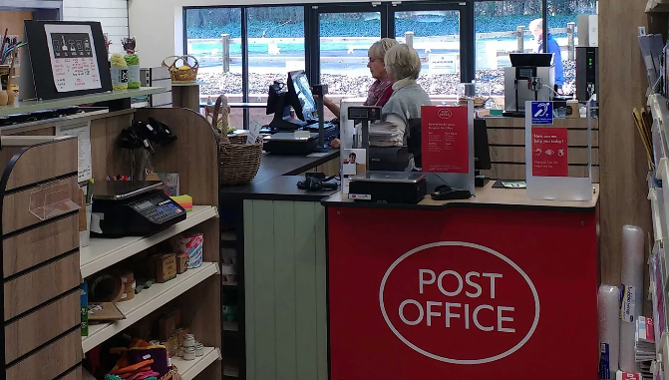
Integrating this with the expanded and modernised Village Hall has been a huge success.
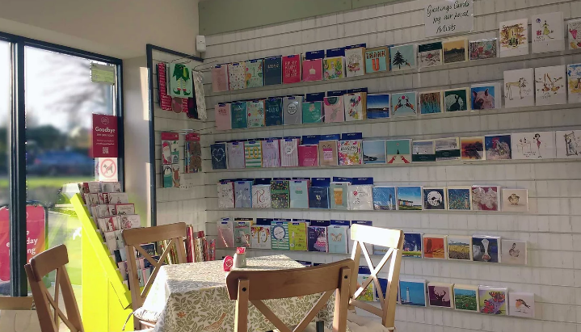

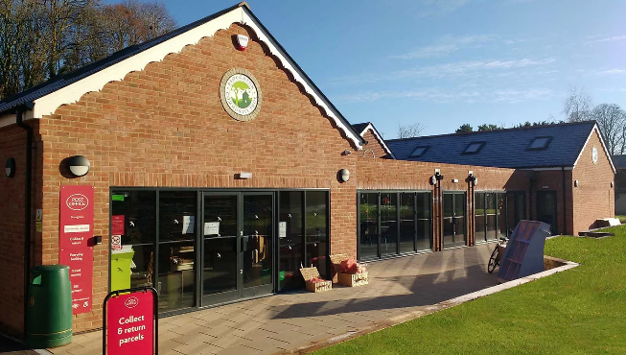

Mid-Test Matters Page | 3

What does Affordable Housing mean?
Affordable Housing means many different things to different people, but one key factor is the cost of buying or renting a home. Obviously, the cost of running that home also contributes to affordability, but we are only covering here the cost of buying or renting a home.
There is an affordability index used by Government and others looking at house prices and people’s income and ability to buy. The median property price in Test Valley was £310,000 in 2020 and the median gross income £35,083. Dividing house price by income gives a ratio of 9.76 – this is called the Affordability Index. A household is considered able to afford to buy a home if it costs 3.5 times the gross household income, or an Index of 3.5!
What does this really mean? For an average cost house in Test Valley and a 20% deposit you need a mortgage of £248,000. Generally, a mortgage company will loan 3.5 times salary or £122,790 if you earn the average. This is simply not enough and first-time buyers, unless they have very big deposits or earn well above the average, cannot enter the market unless there is additional help.
Many households with low incomes have no realistic chance of getting onto the property ladder, or struggle to find suitable private rented housing which is affordable. The median average private rent across the whole of Test Valley is £825 pcm. Based on a household spending no more than 30% of their household income on rent, a household would need income of at least £33,000 for a private rented home to be affordable to them.
The Council uses the term Affordable Housing to describe the different ways it tries to provide that additional help for first time buyers, low-income families and other groups to afford the homes they need to achieve a good quality of life.
In future articles we will look at the different forms of Affordable Housing and how they are provided.
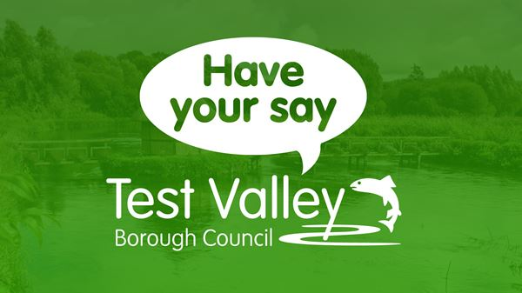

Public asked to shape Borough’s future development plans
Communities are being asked to help shape future development plans as Test Valley Borough Council has launched a consultation on a major planning document.
The Local Plan (Regulation 18 Stage 1) is the first draft of policies and guidelines for new developments. At this stage, it focuses solely on strategic matters and includes the number of new homes required by government, and other strategic planning priorities, such as tackling climate change.
The Council will use people’s comments and feedback to refine the document and draft more detailed policies, which will include identifying the location of major development sites. This additional information will be included in the Regulation 18 Stage 2 Local Plan, scheduled for public consultation later this year.
The consultation will last eight weeks and closes on 8 April. Members of the public can view the Local Plan and submit their comments at www.testvalley.gov.uk/localplan204

Mid-Test Matters Page | 4

Pedalling on as new cycle lane work finishes

A new environmentally friendly transport route between Romsey and Southampton is now in place after four months of work.
The cycle lane has been put in place along the east side of Southampton Road. The lane begins from Lee Lane, running past Romsey Rapids and into the town’s bypass roundabout that helps to connect the rest of Romsey.
The work, which finished two weeks early, means cycling to and from the edge of Southampton and Nursling into Romsey is now safer and easier.
The £300,000 project had been funded by contributions from developers around the town through the Community Infrastructure Levy, having been advocated by Borough and County Councillor, and current Mayor of Test Valley, Mark Cooper, alongside former County Council Leader and local Member, Roy Perry.
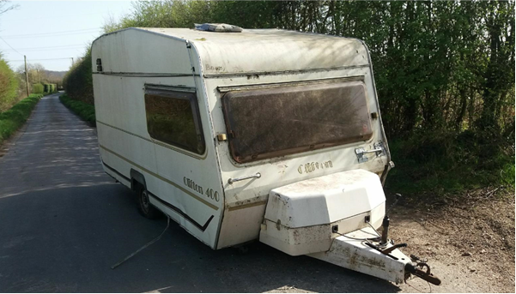

Dumped caravan leaves huge bill for two

Two men have been ordered to pay more than £6,000 in total after a caravan was unlawfully dumped in a rural Wellow lane.
Jason Stone and Jerry Mukoyi were found to be responsible after the vehicle was left along Hackleys Lane, Wellow, in summer last year.
Having received many reports of the dumped caravan, an investigation was launched by Test Valley Borough Council to find those responsible for the dumping, which was also close to St Margaret’s Church. A resident had employed Mr Stone’s business, ‘Scrap my Caravan’ and paid Mr Mukoyi to collect the caravan from an address in Chandler’s Ford.
However, the vehicle towing the caravan was sighted at various locations on its journey before it was finally dumped and was very similar to one belonging to Mr Stone’s second business.
Despite multiple requests Mr Stone failed to attend an interview with TVBC officers who were investigating the fly-tip. Mr Mukoyi attended, however he claimed that he had paid tree surgeons to get rid of the caravan. No evidence was presented for this.
At Southampton Magistrates Court, the pair were made to pay more than £6,000 for various waste offences.
Mr Stone, 40, of Lanfranc Close, Old Sarum, was fined £500, made to pay £572 in costs and a £50 victim surcharge for failing to comply with a S108 notice. Mr Mukoyi, of Gigant Street, was in control of the waste and was therefore fined £4,000, ordered to pay £722 in costs and a £190 victim surcharge. He was also disqualified from driving for three months.
Mid-Test Matters Page | 5

Ukraine
The Rotary Clubs of Andover and Andover Anton, with Borough Councillors, held a fundraising event on Saturday 5th March in the centre of Andover to raise money to support refugees from the conflict in Ukraine. Over £4000 was raised, which with matched funding from Rotary and the UK taxpayer will provide over £8000 to needy families in eastern Europe.

Mid-Test Matters Page | 7

CONTACT


Councillor Alison Johnston

01794 500610

cllrajohnston@testvalley.gov.uk

Councillor Ian Jeffrey

01794 388872

07859955327

cllrijeffrey@testvalley.gov.uk

Councillor Tony Ward

01794 389649

07881812958

cllrtward@testvalley.gov.uk

