
A Christmas edition of the newsletter gives us a chance to wish everyone a small, safe and happy Christmas and to thank all Parish Councillors, Clerks and COVID-19 Community Volunteers for all your hard work in supporting your communities throughout the year.
Mid-Test Matters
Issue 19 20 December 2020
A newsletter from the Borough Councillors of the Mid-Test Ward

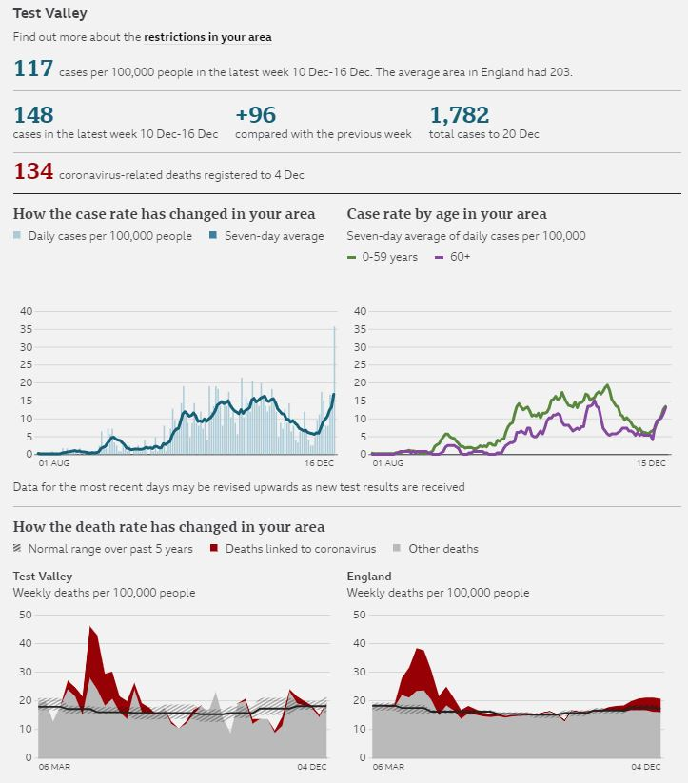
Test Valley Covid-19 data

Support for residents over Christmas

Test Valley Borough Council is urging residents to contact their local support groups early if they require help during the Christmas period due to coronavirus.

Across the borough, community groups have come together in response to the pandemic to pick up medicine, deliver food and run other errands to assist residents who are clinically extremely vulnerable or self-isolating.

Those who will need help over the festive period are being asked to speak to their support groups now to arrange deliveries to enable volunteers to organise their resources and plan around shop and pharmacy closures.

Anyone who isn’t sure who to contact can call the Test Valley Community Helpline on 0330 400 4116 Monday to Friday, 9am to 5pm, and they will put them in touch with their local group. This helpline will be open up to and including Wednesday 23 December.

Between Thursday 24 December and Sunday 3 January, anyone who requires urgent food or prescription deliveries can call the Hampshire Coronavirus Support and Helpline on 0333 3704000, between 9am and 4.30pm. The Hampshire helpline will be open for emergency calls every day except for Christmas Day.

Vaccine

More than 137,000 people in the UK have received the first dose of the Pfizer/BioNTech COVID-19 vaccine in the first week of the largest vaccination programme in British history. The government has released provisional figures which show at least 137,897 people received their first dose of the vaccine by the end of Tuesday 15 December. 108,000 people were vaccinated in England.
With that rollout of vaccinations now underway, Public Health England have produced several guidance documents for specific groups about vaccination.
Guidance for older adults: https://www.gov.uk/government/publications/covid-19-vaccination-guide-for-older-adults
Guidance for healthcare workers: https://www.gov.uk/government/publications/covid-19-vaccination-guide-for-healthcare-workers
Guidance for Social Care staff: https://www.gov.uk/government/publications/covid-19-vaccination-a-guide-for-social-care-staff
Guidance on what to expect after vaccination: https://www.gov.uk/government/publications/covid-19-vaccination-what-to-expect-after-vaccination
Guidance on eligibility and vaccine supplies: https://www.gov.uk/government/publications/covid-19-vaccination-why-you-are-being-asked-to-wait

Unity will be supporting the Andover Primary Care Network with the rollout of the Covid-19 vaccines.
If you are able to commit regularly anytime during the week or at weekends and are willing to assist with this important rollout, visit: https://bit.ly/3qofWxj or call 0330 4004 116 for more information.
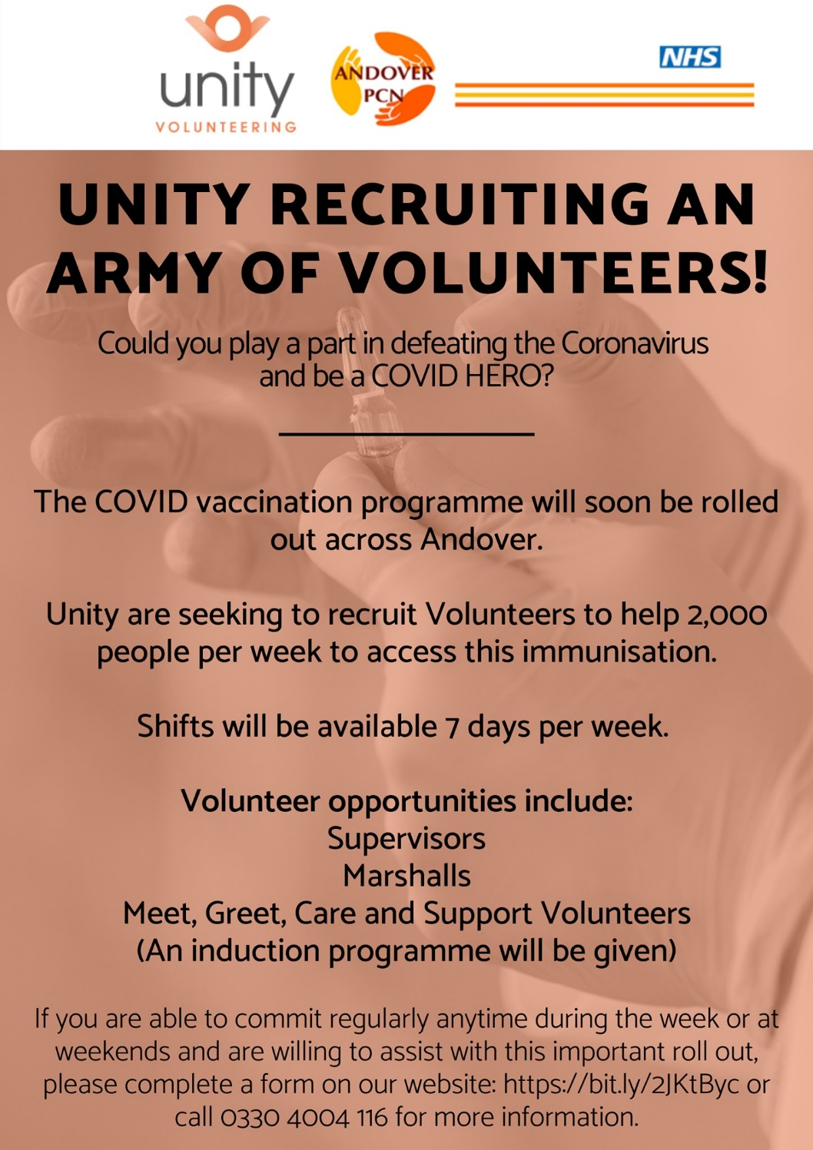

Helping Older Residents get online over the Festive Period
Getting online and using the internet to connect with family and friends can feel very daunting for people who aren’t digitally confident. It can be a source of stress, but staying in touch with the outside world at this time can have huge benefits for our mental health.
There are many organisations who have created guides on using the internet and platforms that can keep us in touch with our loved ones. These are specifically for older people or anyone with limited digital experience as well as helpful hints and tips for family and friends to help this learning process.
- Action for Elders- https://www.actionforelders.org.uk/keeping-in-touch/
Provides easy to read guides free from tech jargon. It provides information on what a video call is and what kind of equipment is needed. There are also guides on how to make Zoom, Skype, Face Time and video calling on Apple/ Android phones.
- Age UK One Digital Programme- https://www.onedigitaluk.com/knowledge-hub/developing-a-digital-champion-project/digital-inclusion/working-with-older-learners/
This has some fantastic resources and tips when it comes to working with older people and helping them use the internet.
- Digital Unite- https://www.digitalunite.com/technology-guides
Have 400+ online guides for new internet users, these cover a whole host of digital topics. Written by subject matter experts and updated daily, the guides are perfect for supporting others with digital skills or improving your own knowledge.
- The Good Things Foundation- https://www.goodthingsfoundation.org/sites/default/files/research-publications/older_people_handbook_0.pdf
Provides a guide and top tips on how to help and support older people who are new to using technology.
- Learn My Way- https://www.learnmyway.com/
Contains over 30 free courses designed to help beginners get started with the online basics - using a mouse, keyboard, setting up email accounts and using internet search engines - while also offering plenty to help people develop their digital skills further.
- Toolkit by Good Things Foundation and Centre for Aging Better on helping older people use the internet- https://www.onlinecentresnetwork.org/sites/default/files/a6_your_guide_to_helping_older_people_use_the_internet.pdf
Is an incredibly useful document full of helpful tips, including using the right language, staying safe online and a section on the kinds of things you can do online.

Councillor Community Grant
Each year, Mid-Test Borough Councillors use the Councillor Community Grant Scheme to fund fantastic local projects within the Mid-Test Ward. This funding aims to encourage community led initiatives and help residents and communities deliver their ambitions that benefit the local area and wider community.
The Councillor Community Grant can be used towards a huge variety of projects, as long as community benefit forms the basis of its aims. Over the years funding has been used to…
- Purchase Speed Indicator devices to encourage the slowing of traffic
- Used towards Village Hall improvements or much needed equipment
- To fund community events, such as the Kings Somborne Fun Day
- To provide Lifelines for older residents
- Repair play areas
- Landscaping costs to encourage community use of green spaces
- Towards the advertising and marketing of local initiatives and events
2020 has been an incredibly challenging year, but if you know of a community group or project which could do with some extra funding, be this to put on an event, help provide community facilities, services or anything else you can think of- please do get in touch!
Grants of up to £1,000 are available to fund up to two-thirds of the total cost of the project or activity. Applications are open to voluntary groups, not for profit organisations, Parish Councils and Schools, in relation to their wider community role.
If you are thinking of a community project that could do with some funding support get in touch with your Mid-Test Councillors and applications can be submitted online at: www.testvalley.gov.uk/CCG where more information can be found. An example of how a grant was used is below.

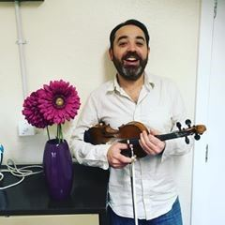
Songs for Seniors

During lockdown, Paul Sartin, Director of the Andover Museum Loft Singers, has created a set of music videos for circulation in elderly care and community settings which has now benefitted from a £500 Community Councillor Grant from Test Valley Borough Council.
The songs have been selected by older people, and include classics ranging from I Love Paris, to Blue Moon and You Are My Sunshine. The idea behind this project is to provide entertainment and stimulation for the older community, many of whom may feel isolated during lockdown.
Research has found that music can enhance mood and that pleasing melodies can deliver benefits for both physical and mental health, including memories and important social connections.
The lyrics to all the songs are provided so that people can sing along. They can be accessed via a YouTube link and also on USB sticks which can be provided to community members by contacting the museum director.
As well as the £500 community councillor grant from TVBC, the Andover Museum Loft Singers also contributed £250 that they raised themselves towards the project.
The Andover Museum Loft is a non-auditioning community choir of nearly 20 years, based in the Iron Age Museum. The choir performs at community and charitable events across the borough, including Andover Rocks, the Weyhill Christmas Fair and at the Hawk Conservancy Trust.
Waste Bin Collections
Revised bin collection dates over Christmas! From next week, your collection days may change as part of the festive period on our rounds. Some of the revised dates have already happened, so make sure to double check!
We know it's been a tough year, so we'll be on hand to empty our LRCs too for any glass bottles you may happen to get through, too. And, don't forget, from the week commencing December 28, we'll also accept bags of waste beside your black bin.

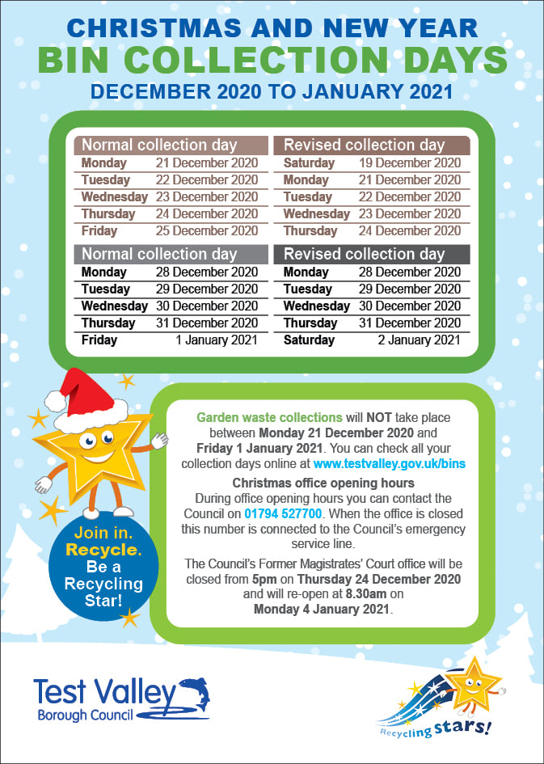

Our Contact Details
Councillor Ian Jeffrey cllrijeffrey@testvalley.gov.uk 01794 388872
Councillor Alison Johnston cllrajohnston@testvalley.gov.uk 01794 500610
Councillor Tony Ward cllrtward@testvalley.gov.uk 01794 389649

