
Mid-Test Matters
Issue 13 1st July 2020
A newsletter for Parish Councils from the Borough Councillors of the Mid-Test Ward

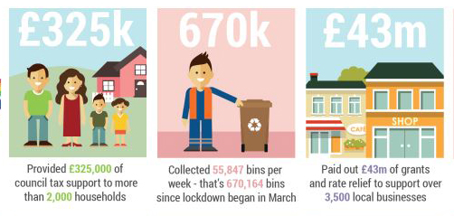
Supporting our Communities through Coronavirus




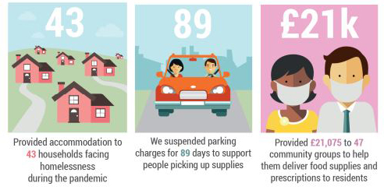

Planning Appeals
Planning applicants have the right to appeal and the results of those appeals can be a guide as to whether planning inspectors agree with our Officers judgement or not. In the 12 months April 2019 to March 2020 there were 39 appeals. In 33 of these planning applications the Councils Planning Officers using delegated powers refused permission. In only 2 of these cases did an Inspector disagree and allow the appeal.
In 6 of the 39 appeals the Council decision had been made at a planning committee. In 2 cases the Officers recommended permission, the Committee disagreed but then the Inspector agreed with the Officers and allowed the appeal. In the other 4 applications the Officers, Committee and Inspector all agreed that the application should be refused.
Appeal from Southern Water
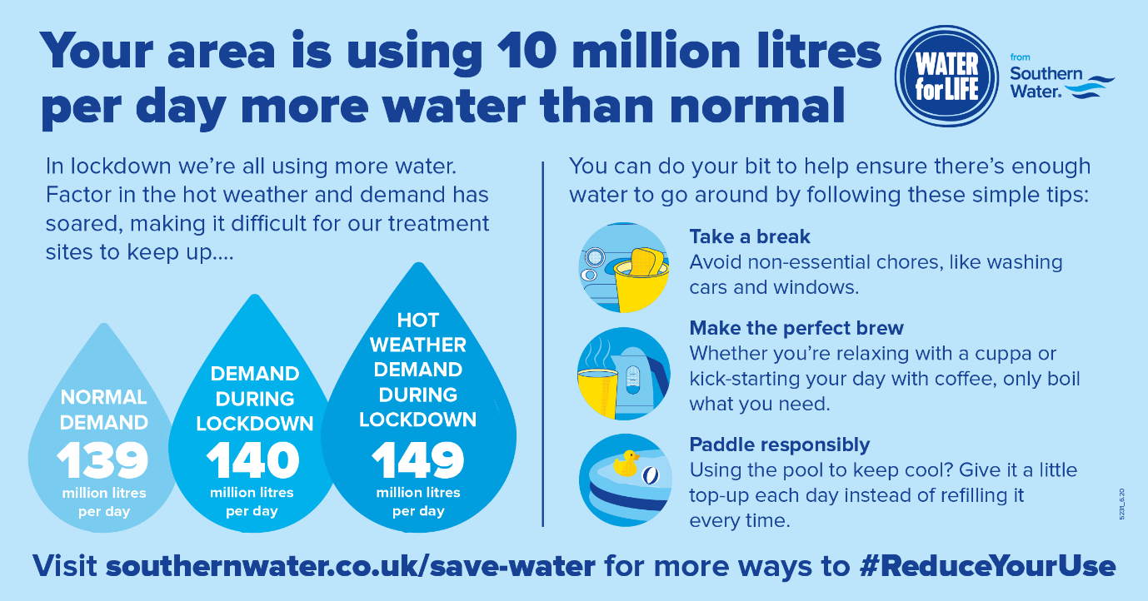
Grant Opportunities for Schools
The Department for Education has launched the COVID Summer Food Fund which will enable children who are eligible for benefits-related free school meals to be supported over the summer holiday period: https://www.idoxopen4community.co.uk/testvalley/News/View/GRUKBP3!N72143
For any queries, please email:
- freeschoolmeals@edenred.com for schools
- freeschoolmealsparentscarers@edenred.com for parents and carers

Funding is also available to help schools to help cover costs relating to specific items up to the end of the 2019 to 2020 summer term: https://www.idoxopen4community.co.uk/testvalley/Scheme/View/School-Funding-Exceptional-Costs-Associated-with-Coronavirus-COVID-19-GRUKBP3!S45318?bcr=MTIzNQ
This has a maximum value of £75,000. There will be some instances where schools face additional costs as a result of the coronavirus (COVID19) outbreak and will not be able to cover these from their existing resources. This funding will support those cases.
Applications must be submitted by the 21 July 2020 deadline. Applicants will need a DfE Sign-In Account.
Review of SHELAA sites nearing completion
A review of the Strategic Housing and Economic Land Availability Assessment (SHELAA) following the Council’s call for sites late last year has been completed and has been circulated to Borough Councillors. The document forms part of the evidence base for the next Local Plan Development Plan Document.
The purpose of a review is to make sure we have the most up to date information on sites promoted for inclusion within the SHELAA and not to comment on the merits of those sites submitted by third parties.
Please note that the inclusion of the site within the SHELAA document does not imply that the Council would necessarily grant planning permission for development use nor does it imply that it will be allocated for development in a future Development Plan Document.
These documents shall also be sent out for the attention of Parish Councils in due course; it is intended to publish the SHELAA on the Council website early July.
We always urge all Parish Councils to study these documents carefully as soon as they are received.
Review of Test Valley Tourism
In October 2019 the council commissioned consultants to review how the authority promotes Test Valley to potential visitors, and in turn, supports the local economy. Following six months of work, the report has now been made available on the Council’s website. It can be accessed here: -
https://www.testvalley.gov.uk/communityandleisure/tourism/visiting-test-valley
The report predates the Covid-19 pandemic and national lockdown, but forecasts potential for the tourism economy through more UK holidays.
Coronavirus Grants Update
The first grant payments under the Local Authority Discretionary Grants Fund have just been made. Approximately 220 applications were received by the closing date and 41 grants totalling £275,000 have already been paid. Work has also continued to pay the small business and retail grants. A further 16 grants totalling £175,000 were included in the last payment run.
Plans to ease guidance for over 2 million shielding
From Monday 6 July, those shielding from coronavirus can gather in groups of up to 6 people outdoors and form a ‘support bubble’ with another household. Government shielding support package will remain in place until the end of July when people will no longer be advised to shield. From Saturday 1 August, the guidance will then be relaxed so clinically extremely vulnerable people will no longer be advised to shield, but support will remain available from NHS volunteers and local councils. People will retain their priority for supermarket delivery slots, and still be able to access help with shopping, medication, phone calls and transport to medical appointments.
Mid-Test Covid19 Deaths
We are becoming used to being bombarded by coronavirus numbers but when that data is close to home it has a greater impact. In Mid-Test we live in close-knit communities and most people will know of those in our communities we have tragically lost to this dreadful virus. The ONS now publishes data and an interactive, map of local information. The area I have shown in the screen shot from the map roughly equates to Mid-Test and can be found here: -
https://www.ons.gov.uk/peoplepopulationandcommunity/healthandsocialcare/causesofdeath/articles/deathsinvolvingcovid19interactivemap/2020-06-12
Points on the map are placed at the centre of the local area they represent and do not show the actual location of deaths. The size of the circle is proportional to the number of deaths

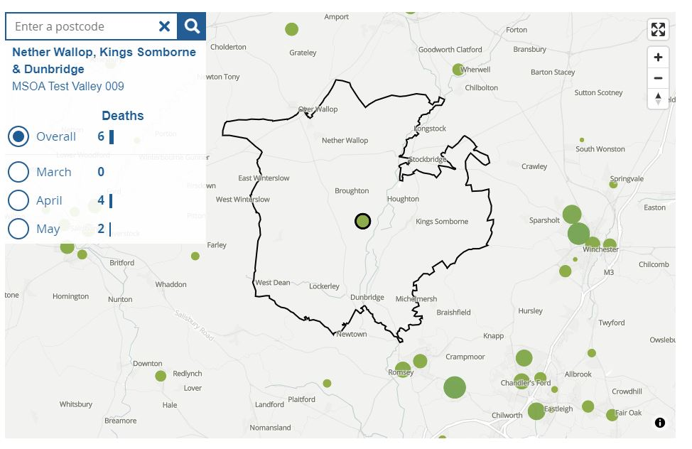
Staying in Contact
Increasingly, our Parish Councils are holding meetings via telephone or video conferencing and we are all adapting to these new ways of working. If you need to speak to Borough councillors outside of meetings, our contact details are below

Our Contact Details
Councillor Ian Jeffrey cllrijeffrey@testvalley.gov.uk 01794 388872
Councillor Alison Johnston cllrajohnston@testvalley.gov.uk 01794 500610
Councillor Tony Ward cllrtward@testvalley.gov.uk 01794 389649

