Mid-Test Matters
Issue 27 03 October 2021
A newsletter from the Borough Councillors of the Mid-Test Ward
Coronavirus Update
We think this is a good summary of the current rules and how the situation might unfold in England as we head into Autumn and Winter. This is different in the devolved nations. For England there is a Plan A and Plan B depending upon: -
- the number of hospitalisations
- rapid rates of change in figures
- the overall state of the NHS
Plan A
- Covid booster jabs are being offered to about 30 million people, including the over-50s, younger adults with health conditions and frontline health and social care workers.
- Healthy 12 to 15-year-olds are being offered a single dose and unvaccinated people are being encouraged to get jabbed.
- The continuation of NHS Test and Trace and free PCR tests
- Encouraging free flu vaccine take-up and Alma Road Surgery are already doing theirs at the Crossfield Hall for example.
- Reminding people to let in fresh air when meeting indoors and to wear face coverings in crowded places
Plan B
If Plan A isn't sufficient to prevent "unsustainable pressure" on the NHS, the government can use Plan B, including:
- compulsory face coverings in some settings
- asking people to work from home
- introducing vaccine passports
- Plan B could be brought in at short notice, following "concerning" data.
The current rules in England
- 1m-plus social distancing guidance remains in places such as hospitals and passport control
- Face coverings no longer required by law, but the government "expects and recommends" them in crowded/enclosed spaces
- Some shops and transport operators still require masks
- Anyone with Covid symptoms must self-isolate for 10 days (or until a negative PCR result)
- People who've been working from home should return to the workplace gradually.
The number of Covid-19 cases remains high, so Hands-Space-Face still seems prudent to stay safe through the Autumn and Winter.
Up Somborne plant a Covid tree
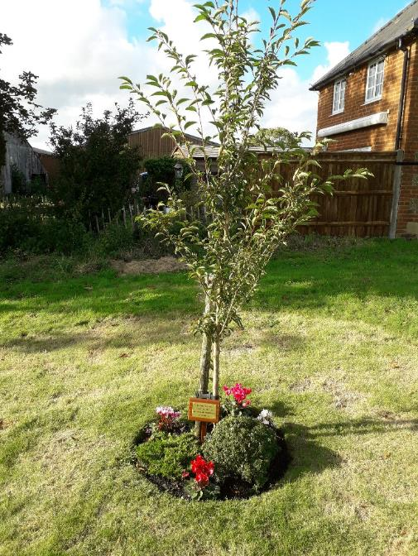

Up Somborne have planted a Covid Tree, (a prunus pandora, or flowering cherry) which was dedicated last weekend. The plaque says, “To commemorate the community spirit in the village during the pandemic of 2020 and 2021”. The funds for purchase of the tree and plaque were raised by garage sale in the village.

Other Borough News
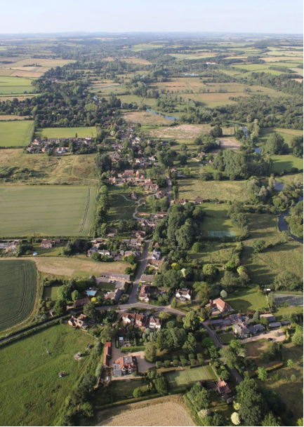
Houghton Neighbourhood Plan
Test Valley Borough Council is consulting on the proposed Houghton Neighbourhood Development Plan, which has been formally submitted by Houghton Parish Council.
The consultation has started, and responses must be received no later than Noon on Tuesday 9 November 2021.

Completed forms can either be emailed to neighbourhoodplanning@testvalley.gov.uk or sent by post to:
Neighbourhood Planning, Test Valley Borough Council, Beech Hurst, Weyhill Road, Andover, SP10 3AJ.
Reference copies of the Houghton Neighbourhood Development Plan and supporting documents, along with paper copies of the representation form are also available at the following locations during their normal opening hours:
Test Valley Borough Council, Beech Hurst, Weyhill Road, Andover, SP10 3AJ.
Andover Library, The Chantry Centre, 53 Chantry St, Andover SP10 1LT
The documents are also available to view at Houghton Neighbourhood Plan and Neighbourhood Development Plan - Houghton Parish Council which includes all the evidence base documents.
Following this consultation the comments received will be passed to an independent examiner, to be appointed by the council, who will consider the representations and recommend whether the Neighbourhood Plan should be put to a community referendum.

West Tytherley, West Dean, Frenchmoor and Buckholt Neighbourhood Plan
The West Dean and West Tytherley Neighbourhood Plan was submitted to the independent examiner, David Hogger BA MSc MRTPI MCIHT on 22 September 2021. The following documents were submitted to the examiner and can be found under the documents tab:
- West Dean and West Tytherley Regulation 16 NDP Submission Document
- Designated Area Map
- West Dean and West Tytherley NDP consultation statement
- West Dean and West Tytherley Basic conditions statement
- Appropriate Assessment under the Habitat regulations. One from Wiltshire Council and one from Test Valley Borough Council.
- A statement of reasons why a Strategic environmental assessment is not required
- West Dean and West Tytherley Regulation 16 representations
- Village Green Defining Evidence
- Evidence base documents
The examiner will consider whether the plan meets certain basic conditions, satisfies legal requirements, and identifies an appropriate area for a referendum.
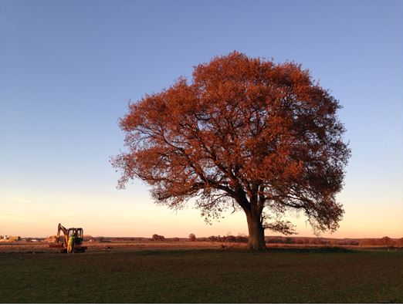
Ash dieback work begins in Andover

Work has begun to fell a number of trees around Andover that have sadly succumbed to ash dieback disease.
Across the UK, a high percentage of ash trees have been infected with the disease (Hymenoscyphus fraxineus) which results in the tree becoming brittle, and eventually leading to it potentially falling down.
As the disease progresses, the risk to the public can increase. The trees have been monitored for some time, but action is now needed to remove them before they become unsafe.
Work has begun in Admirals Way, Andover, before continuing in Gallaghers Copse, Ladies Walk, and Portway Business Park later in the year.
Replanting of areas where trees will be felled will begin late in November and be completed over the winter planting season.
Community and leisure portfolio holder, councillor Ian Jeffrey, said: “It’s incredibly sad to know that so many ash trees across Test Valley and the rest of the UK, have been infected with this disease. We’re committed of course, to replanting these areas as soon as we can, but the safety of the public has to come first and that is what we are focusing on right now.”
Earlier this month, the council committed to planting an additional 10,000 trees across the borough for the next 12 months to help combat climate change. If the land can be found, this will be replicated over the next three years.
For further information, visit www.testvalley.gov.uk/ashdieback, which will be updated with information including the progress of the works, and locations for new planting, and the species chosen.


Major cycle lane works in Romsey to begin

Work on a brand-new cycle lane to help connect Romsey with Southampton is to begin later this autumn.
The Southampton Road cycle scheme will see a bicycle lane put in place from Lee Lane up to the bypass roundabout in the town, running past Romsey Rapids. The £300,000 project has been funded by contributions from developers around the town through the Community Infrastructure Levy.
Now, work has been confirmed to start on October 4 and is estimated to last for four months. There will be a month’s break during Christmas to help prevent congestion over a busy time of year for travel.
The lane will be put in place on the east side of the road, running past Romsey Rapids and into the town’s bypass roundabout that helps to connect the rest of Romsey. It will mean cycling to and from the edge of Southampton and Nursling into Romsey is safer and easier.

Test Valley supports Afghan Refugees

Test Valley Borough Council is working alongside local partners to help refugees from Afghanistan who fled the country following the recent crisis.
The authority, along with colleagues from Hampshire County Council and the NHS, is providing hands-on support to eight families currently staying on a short-term basis in the borough, while plans are made for their futures in the UK.
Leader of Test Valley Borough Council, Phil North, said: “Like you all, I’ve watched in horror at the recent situation in Afghanistan - and despite the harrowing stories that we’ve heard from families that have arrived in the borough - the situation these refugees have been in is something none of us can truly begin to comprehend. I’m, therefore, proud that Test Valley is currently pulling out all the stops to support them.”
“Alongside partners and charities, our officers are working constantly to provide the essential items that these refugees need for the coming days and weeks. Helping them with food, clothes, medical appointments and other needs.”
“Many people have contacted me in recent weeks asking about the support Test Valley is giving Afghan refugees – and I’m pleased to confirm that we will continue to do everything we can to help. It’s my sincere hope that with all of our support they can feel safe and begin to look forward to a better future.”
Whilst the council is grateful for donations that have recently been made via the Unity collection point, Test Valley is not currently seeking any further items.
Note: Due to the sensitivity of the situation and to respect the privacy of the those being supported, we are unable to provide further information on exactly where families are staying.
Places Leisure’s’ Covid Recovery programme
Places Leisure’s have nationally launched a Long Covid Recovery Programme
in partnership with Travis Perkins Managed Services. The Long Covid
Recovery Programme is a new service designed to provide therapy and
rehabilitation specifically for individuals who have had Covid 19 or are affected
by Long Covid. TVBC are delighted to be able to announce that Andover
Leisure Centre and Romsey Rapids are 2 of the 58 settings across the country
delivering this service.
The Council will be working with the operational team at Andover Leisure
Centre and Romsey Rapids to show how the programme will benefit residents
in the local community, and help to the promote the scheme across the
Borough.
Joint Test Valley Association of Parish and Town Councils and TVBC Annual Conference
Kings Somborne village hall recently hosted the annual meeting of Test Valley Association of Parish Councils on a sunny Saturday morning in September. Councillors participated in workshops addressing the topical themes of Climate Change, Mental Health and Localism and how we can respond as a community to these challenges.
Big Boost for Broughton Sports Pavilion
Broughton Parish Council was awarded a CIL grant of £200,000 for the construction of a replacement sports pavilion. This was very timely as investment in such facilities in rural communities is even more critical given the past 18 months. We look forward to the plans taking shape.

Councillor Ian Jeffrey cllrijeffrey@testvalley.gov.uk 01794 388872
Councillor Alison Johnston cllrajohnston@testvalley.gov.uk 01794 500610
Councillor Tony Ward cllrtward@testvalley.gov.uk 01794 389649

