Mid-Test Matters
Issue 15 1st September 2020
A newsletter for Parish Councils from the Borough Councillors of the Mid-Test Ward
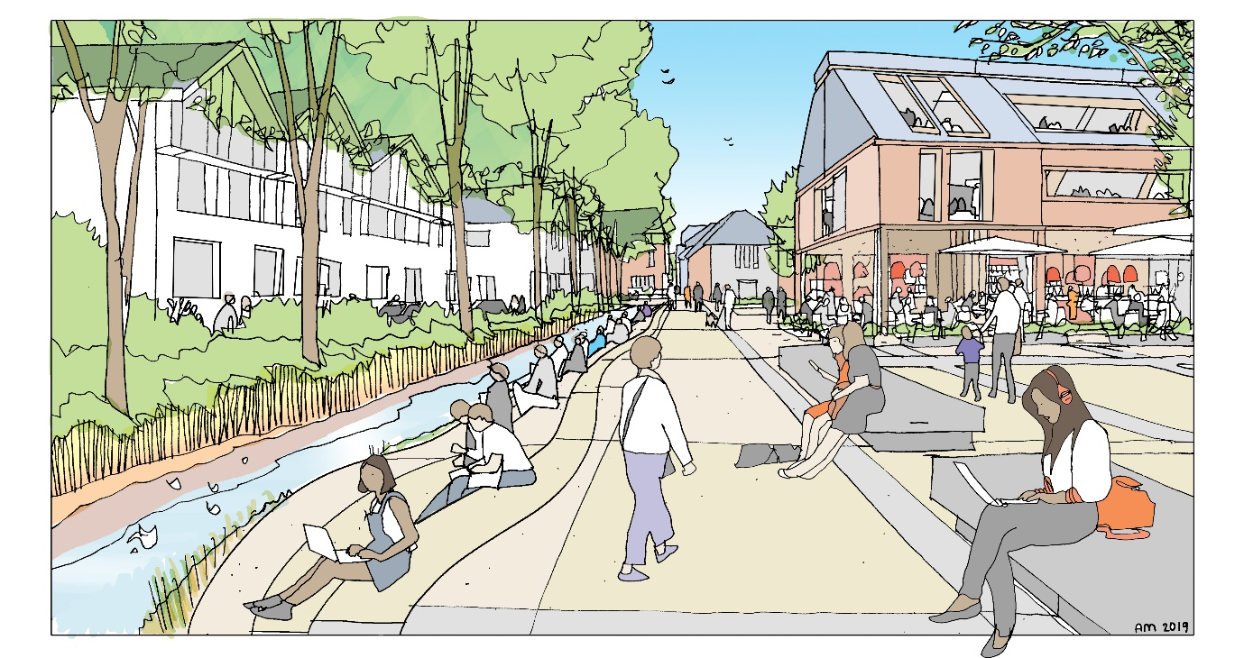
South of Town Centre masterplan
A video has been produced to give a brief tour of the area south of Romsey's town centre, ahead of the masterplan publication. This video reflects how the area currently stands and what the impact of any potential redevelopment could be, once work starts when guided by the masterplan document. This is going to council for adoption on September 2.
You can watch the video, here: https://youtu.be/rY4dI8v-JFw
The Masterplan has been developed by the residents of Romsey with the Council organising public consultations, working groups and for the first time a Citizens Assembly. It means there is now a short, medium- and long-term plan to see this key part of Romsey developed to enhance its value to residents and visitors alike.
Remote Meetings
Zoom, Teams, WhatsApp, Facetime and Skype are now amongst the video conferencing facilities we have had to get used to for meetings, friends and family. As the council and some Parish Councils continue to operate remote meetings its worth considering ways of enhancing the value of the technology. The Centre of Public Scrutiny have produced some guidance on this and although there is a lot about meetings proceedings there is some good guidance on where to sit and what lighting to use which makes a huge difference to what appears on the screen. The guidance can be found here: -
https://mcusercontent.com/665ea61e9b50f31d900a12e7e/files/27d006e3-81ba-4286-8a02-eba835e90e71/CfPS_Tips_on_Behaviour_and_Etiquette.pdf

Romsey Flood Alleviation
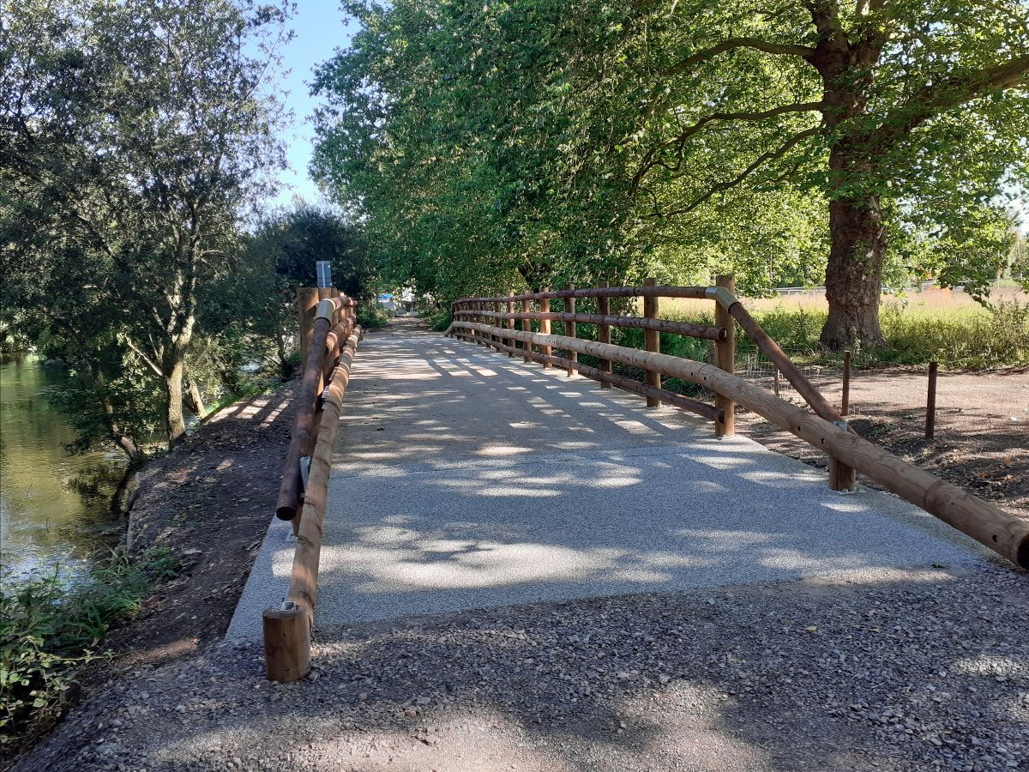

A significant milestone in the Romsey Flood Alleviation Scheme was reached on Monday 3 August with the opening of the new bridge on The Causeway, Romsey.
The spillway under the bridge will allow any floodwater that builds up on the flood plain to the West of Romsey to re-enter the River Test and is part of the wider scheme to reduce the risk of flooding in Romsey.
These works are being implemented by the Environment Agency in partnership with Hampshire County Council and Test Valley Borough Council

Council granted injunction to tackle illegal encampments

The High Court has today granted an injunction order to Test Valley Borough Council to prohibit the setup of unauthorised encampments.
The news follows a spate of incidents last summer, which saw travellers target various sites across the borough, with Andover particularly hard hit.
The injunction should now make it easier for the council to disperse, and potentially prosecute, encampments that set up on particular areas of land.
The court has also agreed to attach a power of arrest to the order, which means that those moving onto land or setting up camp in breach of the order, can be arrested and taken to court.
As well as prohibiting encampments, the injunction also covers any stationing caravans or mobile homes set up without the permission of the landowner, and those who deposit controlled waste in the defined areas.
The injunction applies to named individuals who have targeted parts of the borough previously as well as those who are new to the area.
Business support hotline launched across Test Valley


Test Valley Borough Council has launched a new free service to help support businesses in the wake of the Covid-19 pandemic.
A new hotline is now available for businesses across the borough who would like help and guidance, as well as those who are thinking of starting up a new company in Test Valley.
The council has employed Enterprise South to run the service for the next six months from July, with a hotline available and an email address that can be contacted.
This new service is in addition to the authority’s Business Incentive Grants, Independent Retailer Grants and the Andover Skills Training Fund.
Enterprise South is a non-profit local agency and has been supporting businesses for more than 30 years.
Businesses can contact the helpline via 0844 225 3130 or email info@enterprisesouth.co.uk

Staying in Contact
We continue to have meetings via telephone or video conferencing where we can and we are all adapting to these new ways of working. If you need to speak to Borough councillors outside of these meetings, our contact details are below

Our Contact Details
Councillor Ian Jeffrey cllrijeffrey@testvalley.gov.uk 01794 388872
Councillor Alison Johnston cllrajohnston@testvalley.gov.uk 01794 500610
Councillor Tony Ward cllrtward@testvalley.gov.uk 01794 389649

