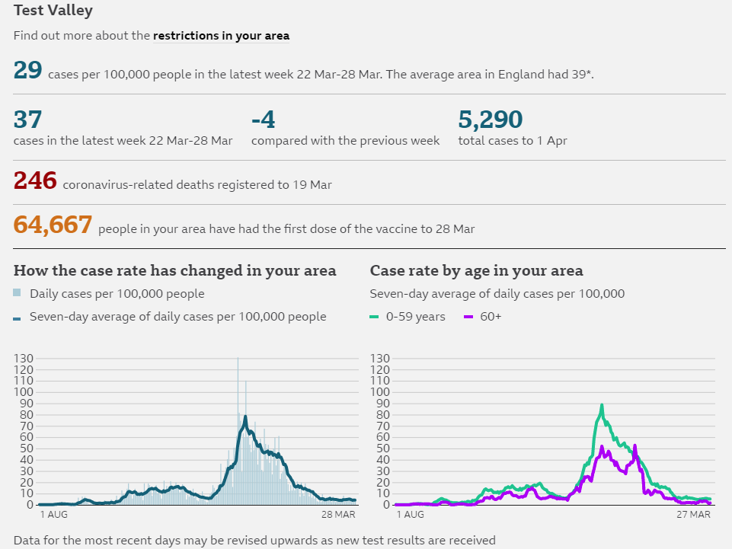
Mid-Test Matters
Issue 22 04 April 2021
A newsletter for Parish Councillors and Community Volunteers

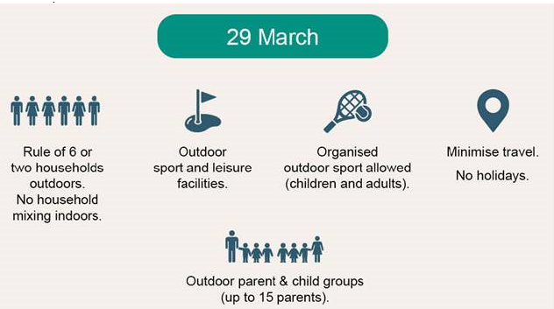
Upcoming changes on 29 March
Some of the rules on what you can and cannot do will change on 29 March as we enter Phase 2 of Step 1 of the Government’s Roadmap
The main changes from the 29 March are:
- you will be able to meet outdoors either in a group of 6 (from any number of households), or in a group of any size from up to 2 households (each household can include existing support bubbles, if eligible).
- you will be able to take part in formally organised outdoor sports with any number of people (outdoor sports venues and facilities will be able to reopen).
- childcare and supervised activities will be allowed outdoors for all children.
- formally organised parent and child groups will be able to take place outdoors for up to 15 attendees. Children under 5 will not be not counted in this number.
Roadmap: https://www.gov.uk/government/publications/covid-19-response-spring-2021
Coronavirus Restart Grant Scheme
The Restart Grant scheme supports businesses in the non-essential retail, hospitality, leisure, personal care and accommodation sectors with a one-off grant, to reopen safely as COVID-19 restrictions are lifted. Eligible businesses in the non-essential retail sector may be entitled to a one-off cash grant of up to £6,000 from their local council. Eligible businesses in the hospitality, accommodation, leisure, personal care and gym sectors may be entitled to a one-off cash grant of up to £18,000 from their local council.
Guidance: https://www.gov.uk/guidance/check-if-youre-eligible-for-a-coronavirus-restart-grant
Mental & Physical Health
There will be many lessons to learn from the Covid-19 pandemic but high up the list must be the impact it has had on people’s mental health and the state of the nation’s health before the pandemic and our ability to survive it. The Government is launching two initiatives which ultimately will rely on local communities and local government working together to make the whole nation mentally and physically fitter.
COVID-19 mental health and wellbeing recovery action plan
The government has published its COVID-19 mental health and wellbeing recovery plan which sets out an ambitious, cross-government, whole-person approach to promoting positive mental health and supporting people living with mental illness to recover and live well.
While this plan sets out what government will do in the coming year, it is also a call to action for the whole of society, for local communities, families and for individuals, who can take simple steps to look after their own wellbeing and the wellbeing of those around them – and can reach out for support, including from mental health services when necessary.
Plan: https://www.gov.uk/government/publications/covid-19-mental-health-and-wellbeing-recovery-action-plan
New Office for Health Promotion to drive improvement of nation’s health
The new Office for Health Promotion will lead national efforts to improve and level up the health of the nation by tackling obesity, improving mental health and promoting physical activity.
The Office will recruit an expert lead who will report jointly into the Health Secretary and the Chief Medical Officer, Chris Whitty. The Office’s remit will be to systematically tackle the top preventable risk factors causing death and ill health in the UK, by designing, implementing and tracking delivery policy across government. It will bring together a range of skills to lead a new era of public health polices, leveraging modern digital tools, data and actuarial science and delivery experts.
Announcement: https://www.gov.uk/government/news/new-office-for-health-promotion-to-drive-improvement-of-nations-health
Health and Wellbeing online learning programme
Please find a list of online health and wellbeing courses available from Hampshire Library Service, there are a variety of courses available from Mindful Experiences to singing, fitness, basic first aid and many more. Click here to view the list of courses.

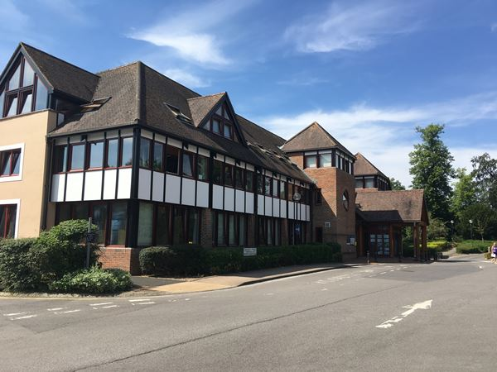
TVBC pushing on with climate action

Plans to help tackle climate change and protect the environment are pushing forward as Test Valley Borough Council cracks on with implementation of the Climate Emergency Action Plan.
Back in September 2019, the council declared a climate emergency, and spent the next six months putting together a plan to ensure the authority is as green as possible.
Now, after initial feedback last autumn, the council has updated the Overview and Scrutiny Committee on the progress that has been made over the recent winter months.
Three new waste collection vehicles with electric bin lifts, lower energy-consuming lighting for the Chantry Centre car park and a renewable energy guarantee for the council’s electricity supply are just some of the positive changes made.
Looking to the future, a recently completed study on renewable and low carbon energy potential will help contribute to the next Local Plan, as the council works towards settings out the future planning policies. Businesses have also benefitted, with the authority working together with external organisations to help local businesses secure more than £100,000 in grant funding to undertake energy audits and launch low carbon projects of their own.

Support for countryside protection in Test Valley


Measures to further protect areas of countryside in southern Test Valley have been supported by councillors after a full meeting.
The motion means the authority is now backing the principle for the further measures, which could include the creation of a green belt, that could protect the countryside between towns and villages in the south of the borough.
The idea of a green belt or other forms of protection would mean Test Valley Borough Council continuing to work alongside other authorities in the county, such as Southampton City Council and Portsmouth City Council in helping to designate appropriate areas for future protection from development. Southern Hampshire would be covered by these potential added measures, including areas between Portsmouth and Southampton, which could mean protection for the south of Romsey and the surrounding areas.
The proposal would mean local authorities, including TVBC, being relied upon to consider urban and brownfield sites for development, before being able to sanction development in the countryside.
At a full council meeting, members voted in favour of supporting the principles for further protection belt’s creation, which is being proposed by countryside charity, CPRE Hampshire. Their campaign has amassed around 15,000 signatures for the creation of the belt.

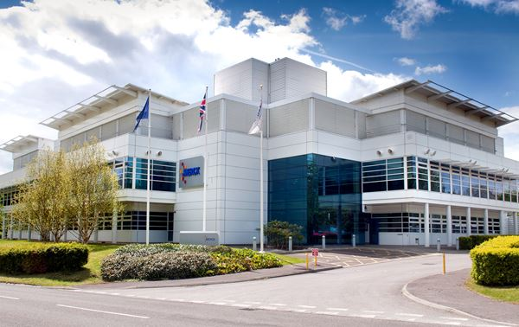
Financial boost for cutting edge entrepreneurial scheme

An innovative scheme for entrepreneurs has been awarded tens of thousands of pounds in grant support from Test Valley Borough Council. Southampton Science Park’s Catalyst business accelerator programme, is competitive but, for the successful applicants, it represents a prestigious and fully supportive environment designed to enable start-ups and early-stage businesses to reach their commercial potential.
The Catalyst programme sees successful applicants given funding and support to grow their businesses, through weekly workshops and advice from experts. Towards the end of the six-month scheme, the companies participate in an investor showcase event to further boost their prospects.
Having previously supported participants of the scheme, Test Valley Borough Council has now awarded the project itself, £20,000.

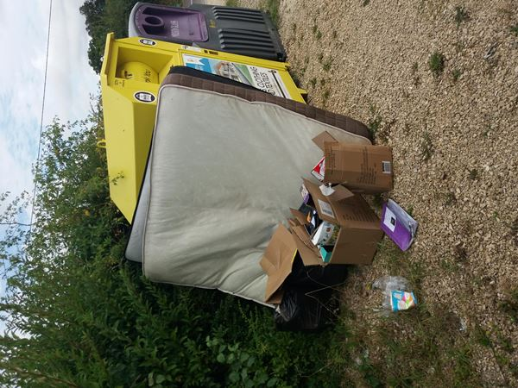
Fine for local recycling centre fly-tipper

A man who dumped mattresses and boxes of waste outside a village hall local recycling centre (LRC) has been ordered to pay almost £1,000.
The man, of no fixed address, admitted to fly-tipping the rubbish, having been paid £25 to remove it by a resident. However, rather than disposing of the waste correctly, he dumped the waste at the LRC in Clanville, near Andover, in August 2019.
An investigation by Test Valley Borough Council then found that he had fly-tipped the waste, which consisted of two double mattresses, boxes of household waste, and black bags of further rubbish.

At Basingstoke Magistrates Court on March 16, he admitted the fly-tipping offence and was fined £60.25, made to pay £827.75 in costs, and a £32 victim surcharge.
Abbotswood Public Art Project
We are really pleased to introduce you to Thrussells, the artistic team who will be leading the designs for the new public art trail at Abbotswood in Romsey. They have created an introductory video on the link below:
https://www.youtube.com/watch?v=IQGENpSbKq4
A new Facebook group for Abbotswood residents has been created to keep residents up to date with opportunities on how to get involved and have their say. https://www.facebook.com/groups/1016323125562556
There will be information shared about how residents can take part in the creative workshops, walks, talks and more as the project develops.
The Legacy Project is successfully funded to support young people across Test Valley from April
‘The Legacy Project’ is a scheme which works with at risk young people to encourage them away from the dangers of drugs, county lines, knife crime and gangs. It is a unique project, funded by the Police & Crime Commissioner, the Test Valley Community Safety Management Group, and TVBC.
The project was piloted in Andover in 2020/21 and was very successful in helping to mentor vulnerable young people with others who have had similar life experiences, to prevent them taking the same wrong options, and signpost to support. The scheme also aims to provide information to others at risk, and support to families. Alongside this, a new linked project ‘Exodus’ provides for a further 12 week intensive support and education programme for those who need additional support, in a Coivd secure way.
The scheme is backed by the Police, TVBC and UpSkillU (a London based project dealing with similar issues) and has proven especially successful in engaging and supporting vulnerable young females from the Andover area.
Due to its impact, demand and nominations from elsewhere in the District, the scheme has now been funded for 2021/22 to operate across the whole Test Valley District with Yellow Brick Road managing the partnership scheme.
The Lights brings back outdoor theatre this summer
After the summer success of 2020 when The Lights brought outdoor theatre to Beech Hurst Park, Andover, the venue is delighted to announce more theatrical delights for this year. Beech Hurst park will play host to BlackBox Theatre with the Noel Coward classic, Blithe Spirit on 19 June, and will then welcome the inimitable Pantaloons on 7 August with Pride and Prejudice. There will be a matinee and evening option for both performances.
The much-loved Pantaloons will already have made an appearance in the town on Wednesday, 4 August with The Wind in the Willows in the beautiful setting of St Mary’s Church gardens. Suitable for all the family, this frantically funny caper will take place at 2pm and 6pm.
For more information about these shows, or to book tickets please visit: www.thelights.org.uk
Physical Meetings to return in May
A letter to councils from Local Government Minister Luke Hall confirming that emergency legislation allowing virtual council meetings will not be extended beyond May 6. This means that all local authorities will need to return to meeting physically in order to comply with legislation.
However a number of national groups including the Association of Democratic Services Officers and Lawyers in Local Government have lodged papers at Court seeking a declaration that remote meetings could legally continue after 7 May 2021 under an existing provision in the Local Government Act 1972. It is expected that we will know the outcome from this hearing by the end April.
In the meantime the Council is planning for how we will return to physical meetings in a covid secure way for the period from 7 May to the 21st June (when it is proposed that all restrictions will fall away).

