Mid-Test Matters
Issue 3 30 June 2019
A newsletter for Parish Councils from the Borough Councillors of the Mid-Test Ward
More Changes to the Southern Area Planning Committee
When the Andover Alliance Party split into two factions with one as a declared political group within the Council and the other as an undeclared political group it put two of their representatives onto the Southern Area Planning Committee (SAP). At Council this week it was resolved and accepted to return to proportional representation for both Southern and Northern Area Planning Committees. This removed the two Andover Alliance councillors from SAP but because the Liberal Democrats have more councillors in southern Test Valley than the Conservatives, they gain three additional seats on SAP, including the Chairmanship and the Conservatives lose one seat. This will be Councillor Ian Jeffrey. This means for Mid Test Councillor Tony Ward is the representative on the committee with Councillors Alison Johnston and Ian Jeffrey free to speak to committee in support or against applications as appropriate.
Nationally renowned design consultancies scoop Andover masterplan contract

It was announced at Full Council yesterday that the authority has selected HemingwayDesign and NEW Masterplanning to lead on the masterplan project to redevelop the town centre. Founded by renowned Red or Dead designer, Wayne Hemingway, and his wife, Gerardine, HemingwayDesign and its partners NEW Masterplanning saw off strong competition from 29 other consultancies to land the contract.

Following the international success of the Red or Dead brand, Wayne and Gerardine launched HemingwayDesign in 1999 and branched out into urban development and housing. Some of their most successful projects include the multi-million-pound scheme to transform the previously derelict Boscombe Overstrand in Bournemouth and create its new beach pods, as well as the Coal Drops Yard shopping and dining district in London.

Their Green Hills housing development in Blackburn won the award for ‘Large Housing Development of the Year’ at the Insider Residential Property Awards 2018 and they are also working on the community-led ‘Blackburn is Open’ project to revitalise the town’s independent retail sector in a bid to boost the economy.

Their partners, NEW Masterplanning, will lead the masterplanning and spatial frameworks for Andover. Established in 2016, the company has expertise in urban design, architecture, landscape architecture, planning, community engagement and graphic design.

They have national and international experience and have led high profile projects in major cities and historic centres including Birmingham, Bath, York, Bristol, Gloucester, Rotterdam and Amsterdam. They also have particular expertise in regenerating small towns and local neighbourhoods. In the south west they have prepared delivery frameworks and public realm strategies for market towns such as Keynsham, Devizes, Bodmin, Midsomer Norton, Corsham and Stroud.

The masterplan process will take around 12 months to complete and will involve significant consultation with the public to decide what the future of Andover will look like. Once the masterplan is in place, the council is likely to appoint a commercial developer partner to start delivering changes in the town

Annual Dementia Festival

Sunday 7th July at Sir Harold Hillier Gardens

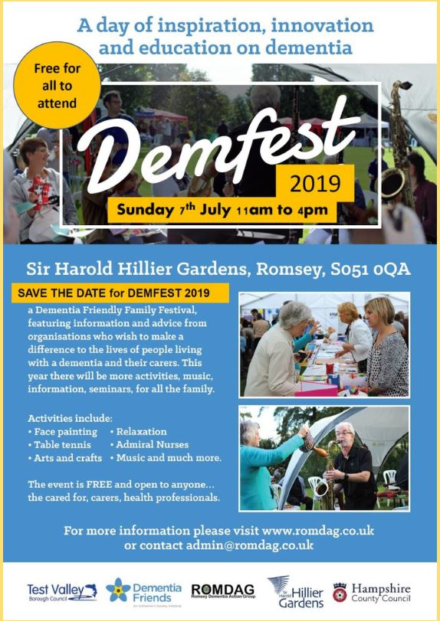
DEMFEST is a free family event, open to anyone, but is aimed at those living with dementia, their families & health professionals. The day provides information, inspiration and innovation for those affected by dementia.

Visitors can expect live entertainment from Jayne Deer, with songs from the 1940s & 50s, Ross Cantrell, Cinnamon Jazz and The Homing. There will be a range of activities including horticulture therapy, reminiscence, aromatherapy, cheerleading and many more.

Numerous information stands will be on hand with representatives talking about the support and advice they can offer those living with a dementia or affected by it.

The Romsey Dementia Action Group, who organise the event are pleased to announce ex Saints Manager Lawrie McMenemy MBE and Caroline Nokes MP will be opening the event at 11.15am.

Your Mid Test Borough Councillors will be attending.

Intervention, Communication, Education’ (ICE) project
'ICE': Following a successful application to the Police and Crime Commissioner, a further three cohorts of young people took part in the ICE programme. In total 37 young people from Andover, Stockbridge and Romsey took part in the scheme. Feedback from
participants and partners continue to have been positive, both in terms of the course and its subsequent impact on attitudes and behaviours.
In December 2018, the partnership project was recognised in the national 'Children and
Young People Now Awards' as a finalist in the Youth Justice category. This is the third
year that the project has been recognised and shortlisted by award bodies, following the Hampshire Fire & Rescue 'Celebrating Success' Awards in 2017, and the National
'Resolve ASB Awards' in 2016. Subsequently, additional funding has been secured from the Police and Crime Commissioner to extend the ICE project to March 2020 with three further tailored cohorts scheduled.

Mid Test Councillor Tony Ward has attended some of the course sessions and presentation ceremonies and found the impact on the youngsters really impressive.

Sports sessions return across Test Valley this summer
Youngsters across Test Valley will be able to benefit from a range of facilities and experience while getting out and about this summer.
Together with partners Hampshire Constabulary and Hampshire Fire and Rescue Service, Test Valley Borough Council is helping to run a number of free community sports sessions in August.
The events will feature a range of sports sessions provided by local clubs and coaches in Andover and Romsey, such as hockey, football, athletics and cardio-tennis.
Open to anyone in Test Valley aged between eight and 15, the events will be held on August 1st at Romsey Sports Centre playing fields and the Charlton Sports Academy on August 19. They will run from 11am until 3pm and spaces on each are limited.
Places are limited and pre-registration is required. To register and for more information, visit www.testvalley.gov.uk/community-sports, or search for Community Sports on the Test Valley website.

Fishlake Meadows Fun Day

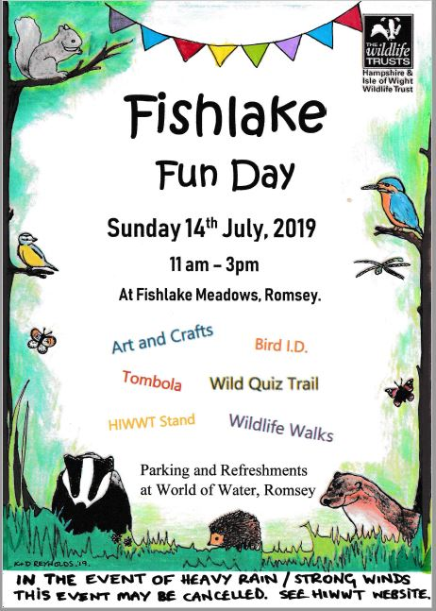
Fishlake Meadows is a wonderful nature reserve acquired by the Borough Council and managed by the Hampshire and Isle of Wight Wildlife Trust (HIWWT). The Trust has already made a fantastic start in the process of bringing the site back to its abundant natural beauty aided by some 140 volunteers. A key objective is to bring the educational benefits of nature to as many youngsters as possible.
This Fun day is planned to do just that with all sorts of activities. Take the family and join in the fun and explore this wonderful asset on the edge of Romsey.

Local Plan comments

Copies of all the comments received during last year’s public consultation will be published on the TVBC website on Monday, 1 July 2019.

There will also be a list of comments made on each of the consultation questions, together with a search facility.

Planning Lists

There was a mixed response to last month’s planning list and suggestions on how the information might be better presented. We are working on this and when we have a more useful format, we will publish it.

Contact
Councillor Ian Jeffrey cllrijeffrey@testvalley.gov.uk 01794 388872
Councillor Alison Johnston cllrajohnston@testvalley.gov.uk 01794 517939
Councillor Tony Ward cllrtward@testvalley.gov.uk 01794 389649

