Mid-Test Matters
Issue 17 1 November 2020
A newsletter from the Borough Councillors of the Mid-Test Ward

Coronavirus updates
The following coronavirus transmission figures are from official government data for Test Valley.
The graph below details the number of daily cases within the past fortnight, and a seven-day rolling average.
Using a seven-day rolling average is viewed as more representative in reflecting the current state of transmission, as the daily data can be changed retrospectively following updates and delays in testing.
This data has been produced at the entire TVBC level, as this is where it remains most reliable. Although more detailed data is available, it does not align to the borough council’s ward boundaries, and therefore the data would have to be ‘moved’ to fit in with these areas, which would alter and mislead the results.
This data was accurate as of 5pm on October 29th, and is publicly accessible. Currently, Test Valley remains below the national average.
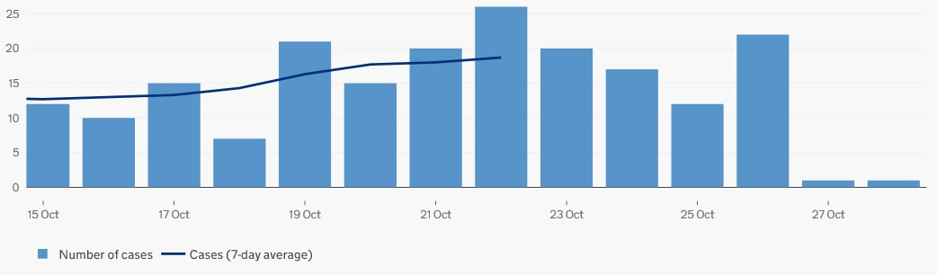
Government has published these latest reproduction number (R) and growth rate over the last week for England and for comparison the South East region which we are in.
R number:
 | 16 October | 23 October
England | 1.2-1.4 | 1.2-1.4
South East | 1.3-1.5 | 1.2-1.5
Growth rate:
 | 16 October | 23 October
England | +4% to +7% | +3% - +6%
South East | +5% to +8% | +4% to +7%

Another source of information is the daily post code look-up on the BBC web site which shows in graphical form the number of cases per 100,000 people. (Test Valley has a population of about 125,000). The BBC data also
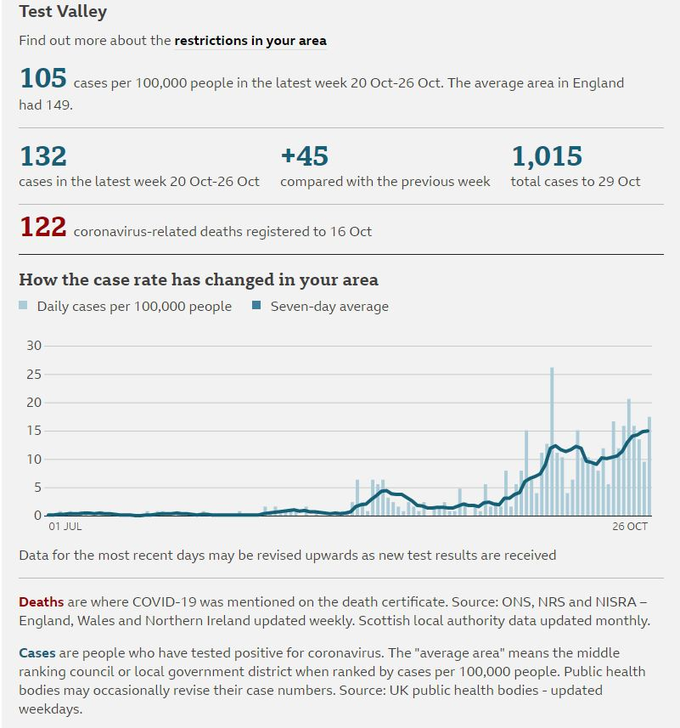

Test and Trace Payments
From 28 September 2020, individuals will be entitled to a Test and Trace Support Payment of £500 if they:
- Have been told to stay at home and self-isolate by NHS Test and Trace, either because they have tested positive for coronavirus or have recently been in close contact with someone who has tested positive.
- Live within the Test Valley Borough Council (TVBC) area

- Are employed or self-employed

- Are unable to work from home and will lose income as a result

- Are currently receiving one of the following benefits:

- Universal Credit, Working Tax Credit, income-based Employment and Support Allowance, income-based Jobseeker’s Allowance, Income Support, Housing Benefit and/or Pension Credit.

The Council will also be able to make a discretionary £500 lump sum payment in exceptional circumstances to an individual who meets the main qualifying criteria for the Test and Trace Support Payment (i.e. they are a low-income worker who is unable to work because they are self-isolating) but is not in receipt of qualifying benefits and could suffer financial hardship as a result of not being able to work, providing they have a minimum income of £80 per week
For the purposes of this scheme a low income is defined as less than
- £384.62 per week (£20,000 a year) joint income if you’re in a couple
- £384.62 per week (£20,000 a year) if you’re a single parent and your children live with you
- £257.69 per week (£13,400 a year) if you’re a single adult

This payment is designed to support people on low incomes, if they will lose income as a result of self-isolating, and to encourage them to get tested if they have symptoms. This is important to help stop the transmission of COVID-19 and avoid further economic and societal restrictions.
The scheme will last until 31 January 2021.
These payments are available from 28 September 2020, the Council will have arrangements in place to administer them by the 12 October 2020. Someone told to self-isolate on or after 28 September (but before the scheme is operational in TVBC) will be able to make a backdated claim for payment.
.
Fly-tip success - again!
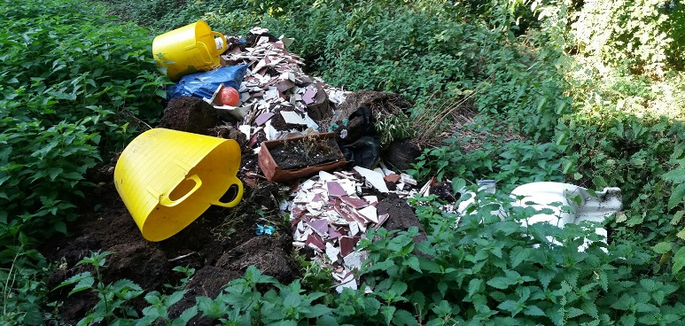

Despite Covid-19 people are still misbehaving and the Council still has its normal job to do
The council has secured a third fly-tipping prosecution within a week after a man admitted dumping waste along Toothill Road, near to Romsey.
He had been driving along Toothill Road in July last year when he dumped a toilet, broken tiles, plastic buckets and plumbing materials on the side of the road. The fly-tip was witnessed, and council officers then began to investigate the matter and the vehicle involved.
Having notified other agencies in an effort to locate the vehicle, the case then came together when patrol officers from Southampton City Council spotted the vehicle involved on Shirley High Street. The patrol team were then able to notify TVBC.
At Southampton Magistrates Court on October 21, the man admitted to dumping the waste. He was handed a £1,600 fine, ordered to pay £839.50 in costs and £240 in compensation. It’s the third fly-tipping prosecution within six days for the council following the guilty pleas of two other individuals
Parish profiles refresh
Over the past few months, the policy team have been refreshing the profiles that cover all of the borough’s 57 parishes. The majority of these are now available on the council’s website, with the remaining profiles being published in the coming months.
The parish profiles look to provide consistent information about local communities across the borough, they look at information on topics such as population structure, economic, housing, health and educational information.
If you have any questions. about a specific area or data set, you are more than welcome to contact us or the policy team.
Combatting modern slavery
Sad to say slavery is still an issue and to help awareness the Modern Slavery Partnership has produced a guide, titled One Minute, to help combat and identify modern slavery.
Did you know that in Hampshire in 2019 there were 195 cases of modern slavery identified, the main types of activity being sexual exploitation, child criminal exploitation, labour such as nail bars and car washes and benefit fraud?
It happens in Hampshire and is on the rise so we all need to be vigilant. If you see anything that doesn’t feel right but not enough to trigger an emergency response, a tiny piece of information could help the police to identify a crime. For example, it could be the number plate of a car frequently taking people from a property at odd hours, or workers looking underage. Please report concerns to the police on their Community Partnership Information Form. https://www.safe4me.co.uk/portfolio/sharing-information/
If you use car washes it may be an idea to download the Safe Car wash app https://www.theclewerinitiative.org/safecarwash. The app will ask a series of questions related to the indicators of modern slavery and if there is a high likelihood that modern slavery is occurring in the hand car wash, you will be asked to report your concerns. This has been successful in helping to stop many cases of forced labour across the country.

Should you have any concerns regarding potential modern slavery or any other safeguarding issue whilst carrying out your role, please complete the safeguarding form on Troutface and one of the safeguarding team can advise you on what to do.
Unity’s Test Valley Impact Survey
Unity, Test Valleys community services provider, have created a Test Valley Impact Survey, aimed at understanding the impact that Covid-19 and its subsequent regulations has had on local community groups. The survey aims to understand the challenges community groups are facing and what recovery for them might look like. The link to the online survey can be found here: https://tinyurl.com/yat293qp, and more details about Unity can be found on their website: https://www.unityonline.org.uk/.
Please forward this information to any contacts you may have with local community groups in your Parish. If you have any questions, or would like any more information please contact Ken Tymms, (ken.tymms@unityonline.org.uk) Unitys Voluntary Sector Support Worker, on 0330 4004 116/ 07909 093794.
Or alternatively Mid-Test’s Community Engagement Officer, Imogen Colley, would be happy to discuss this further (icolley@testvalley.gov.uk, 01264 368958)

Annual leaf clearance

The council’s programmed annual leaf clearance will start on Monday, 26 October and will take six weeks to complete.
We are targeting areas that regularly accumulate a lot of leaves and we are responding to ad-hoc requests to clear debris. We will also clear any large accumulations reported before this date. Unfortunately, the Environment Agency’s ban on the composting of street leaves remains in place.
This means that the leaves we collect are disposed of along with residents’ household waste and do not contribute to the council’s recycling rate
Our Contact Details
Councillor Ian Jeffrey cllrijeffrey@testvalley.gov.uk 01794 388872
Councillor Alison Johnston cllrajohnston@testvalley.gov.uk 01794 500610
Councillor Tony Ward cllrtward@testvalley.gov.uk 01794 389649

