Mid-Test Matters
Issue 9 1st December 2019
A newsletter for Parish Councils from the Borough Councillors of the Mid-Test Ward

Councillor Community Grant
To comply with purdah, the Councillor Community Grant scheme will be put on hold between 8 November to 13 December. During this time the application for councillor community grants will be closed. We will also not carry out any publicity relating to the grants during this period.
The community engagement officers will contact applicants who are working on a grant application to inform them of this and advise that they can save the application and then submit when the grants reopen.
Climate emergency
In September, the council declared a climate emergency and committed to investigate clear and effective options to become a carbon-neutral organisation. This work has been broken down into seven different work-streams each with a cross-party working group, as well as a lead councillor and senior officer support. The work streams are: -
- Digital and Smart Working;
- Working with our Businesses and Communities
- Premises and Asset Management
- Reducing, Reusing and Recycling
- Transport, Fleet and Plant
- Enhancing the Natural Environment;
- Infrastructure and the Built Environment
The working parties are in the process of meeting with officers to confirm the detailed scope of these work-streams and gaining an understanding of what we know and what other organisations are doing.
Trading standards warning

Hampshire County Council’s trading standards has warned that residents are receiving scam calls about blocked drains. Offers are made to clear the drains, and sometimes money is demanded up front. Prices may be inflated and may not be given before the work has begun.
Residents are advised not to agree to work that is instigated as a result of a cold call. At least three written quotes should be obtained from members of the Hampshire County Council Trading Standards Buy With Confidence Scheme or a recognised trade association.
GWR Christmas upgrades
Major changes are being made to the Great Western Railway services from December 15. This means that train times will be changing and the calling patterns for many services may also be different.
To check times and locations, please visit www.GWR.com/timetable2019 . A temporary timetable will also be in place between Christmas Eve to New Year’s Day.
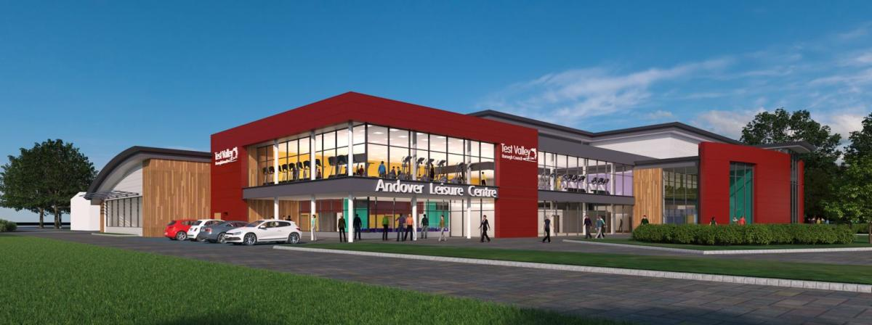
Leisure centre update
At this week’s Council meeting, Portfolio Holder for Community and Leisure, Councillor Tony Ward gave an update on the leisure contract. The updated included that, when Places Leisure took over the contract in May 2017, they had a centre membership of 2,451, which, while in the older leisure centre, they managed to increase by 12 per cent at the end of that year, followed by a further 16 per cent by the time the new centre opened in April.
Swimming membership also increased by 38 per cent in that time. From April this year until September, swim lesson membership increased from 1,211 to 1,336, and centre membership has also risen by 18 per cent in the same six months. In addition, Places Leisure have introduced a ‘swim only’ membership which started with 192 members and has already grown to 295.
The total for all forms of membership has grown from 4,709 to 5,562 in the six months since opening
Another piece of news from The Andover Leisure Centre is the hosting of a women-only swim session in partnership with This Girl Can. The sessions run during term time between 8 January until 25 March next year, every Wednesday between 2pm and 3pm.
A new season springs into life at The Lights!

The new season at The Lights will take you from winter gloom right through to spring 2020!
Talented tributes, comedy and original music will headline the theatre between December and April.
There is plenty in store for theatre lovers of all ages with children’s theatre including Star in a Jar from favourites Pied Piper Theatre in January, and The Curious Garden in April, as well as a whole host of holiday workshops over the February and Easter half term.
The Lights is also delighted to announce that they can now offer a Gift Spotlight Membership just in time for Christmas – the perfect, hassle free gift for any theatre lover!

New Community Hall & Preschool lands in King’s Somborne

A new community hall has landed in King’s Somborne after a two-year project which raised almost £230,000.
The building, which will be a hub for the community, will also be utilised by Sombornes Preschool, who currently use the village hall for a number of their activities. The idea for the new building came as a result of the Neighbourhood Development Plan survey in the community which was undertaken a few years ago, which suggested the need for a new facility.
Test Valley Borough Council contributed £120,000 towards the project, which was delivered and built in the village in the space of 24 hours.
A total of £95,000 came through the Community Infrastructure Levy, which is when the council charges on new development across the borough that meets certain criteria. Those looking to provide new infrastructure, facilities or services can then bid for a share of the levy money. Another £25,000 was then awarded through a Community Asset Fund from the council.

The end product was a result of a cross-party community project team working on behalf of the parish council and the borough authority. The hall will open in the second week of January.
Other organisations to put forward funds included Hampshire County Council, Awards for All, the Lodden Test Leader Programme, King’s Somborne Parish Council and the Village Hall, who ran community fundraising events to contribute £30,000.
Led by Mid Test ward councillor and community and leisure portfolio holder, Tony Ward, the project took around two years to finish.

With the groundwork and services all completed by contractors, the building was delivered in five sections on November 5 and then craned into position.
Councillor Tony Ward said: “I am so hugely grateful for the wider community’s support in this project. King’s Somborne is a unique place and everyone has truly come together to make this happen.
“Now, the village hall will be freed up as the preschool has a new place to call home for some of its activities, and the new hall will also be a new hub for the community to enjoy, too.”
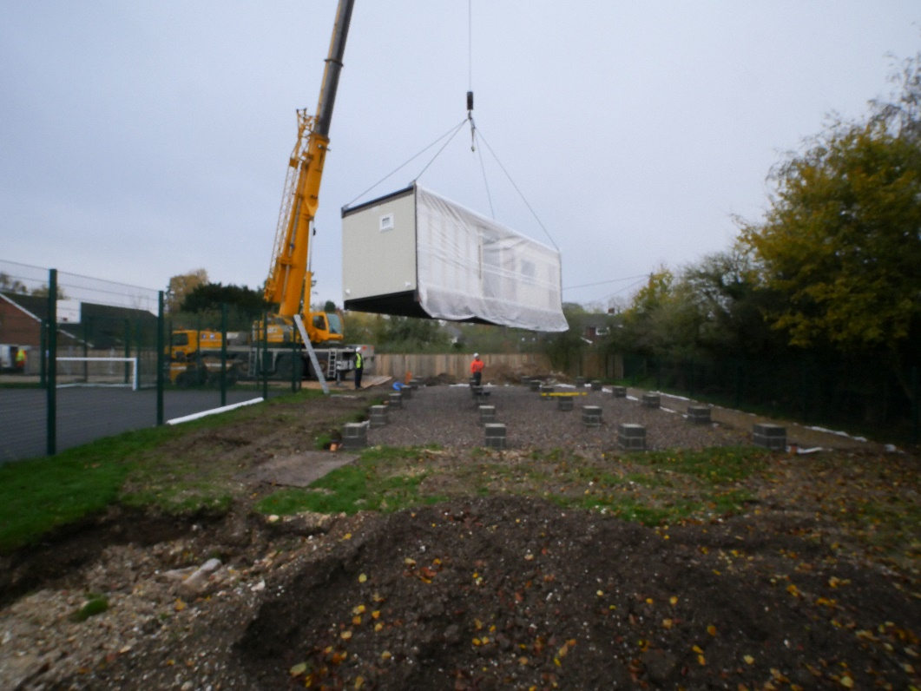

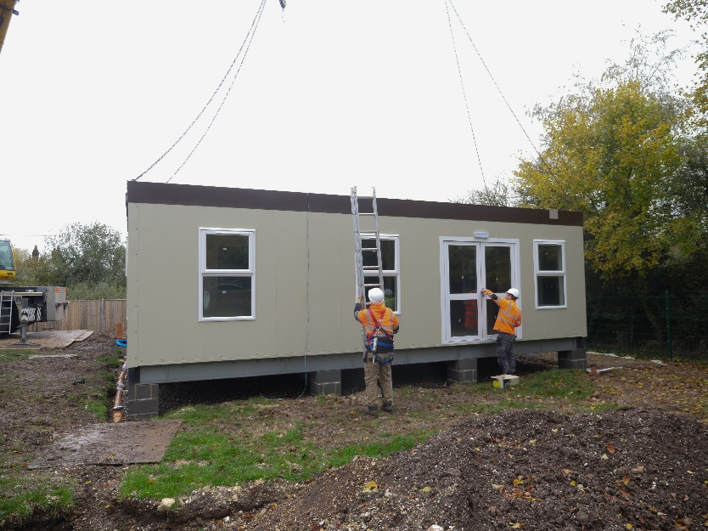

Contact
Councillor Ian Jeffrey cllrijeffrey@testvalley.gov.uk 01794 388872
Councillor Alison Johnston cllrajohnston@testvalley.gov.uk 01794 517939
Councillor Tony Ward cllrtward@testvalley.gov.uk 01794 389649

