Road Map to ease restrictions – we found this chart useful
Mid-Test Matters
Issue 21 01 March 2021
A newsletter from the Borough Councillors of the Mid-Test Ward
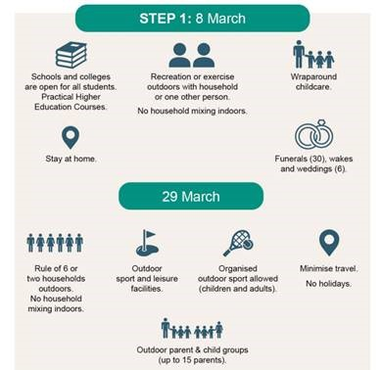
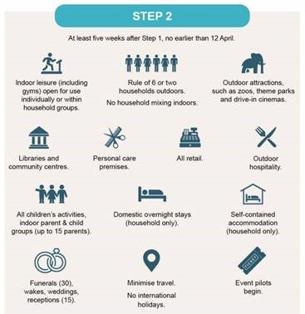
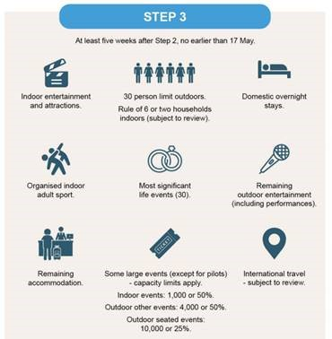
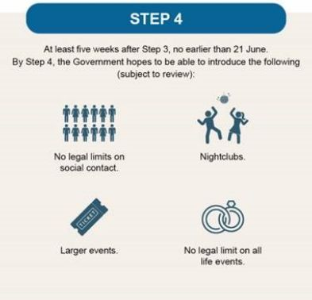
Covid-19 cases in Test Valley continue to fall
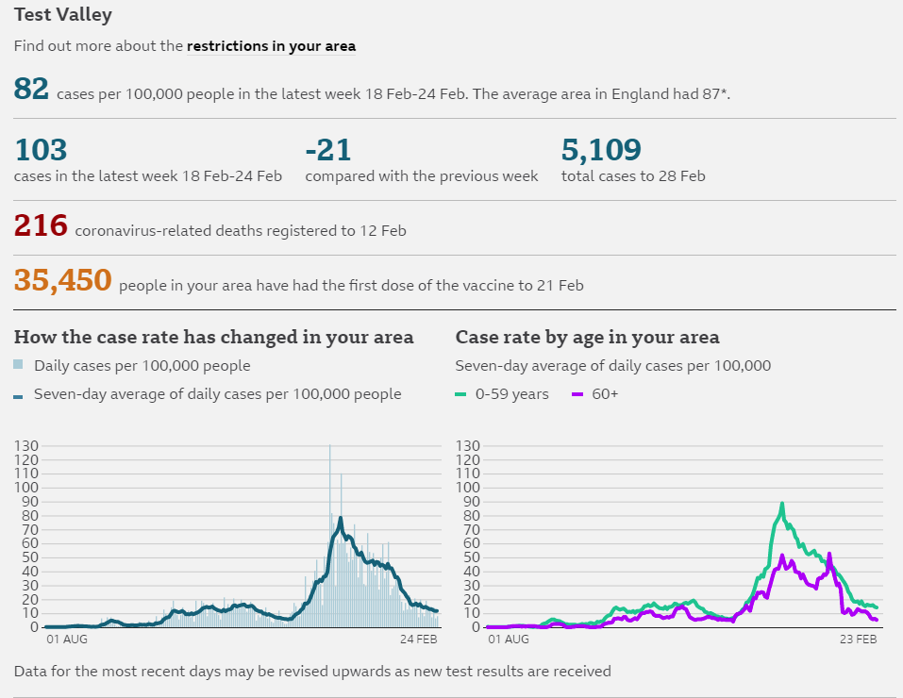
Unsung Hero’s
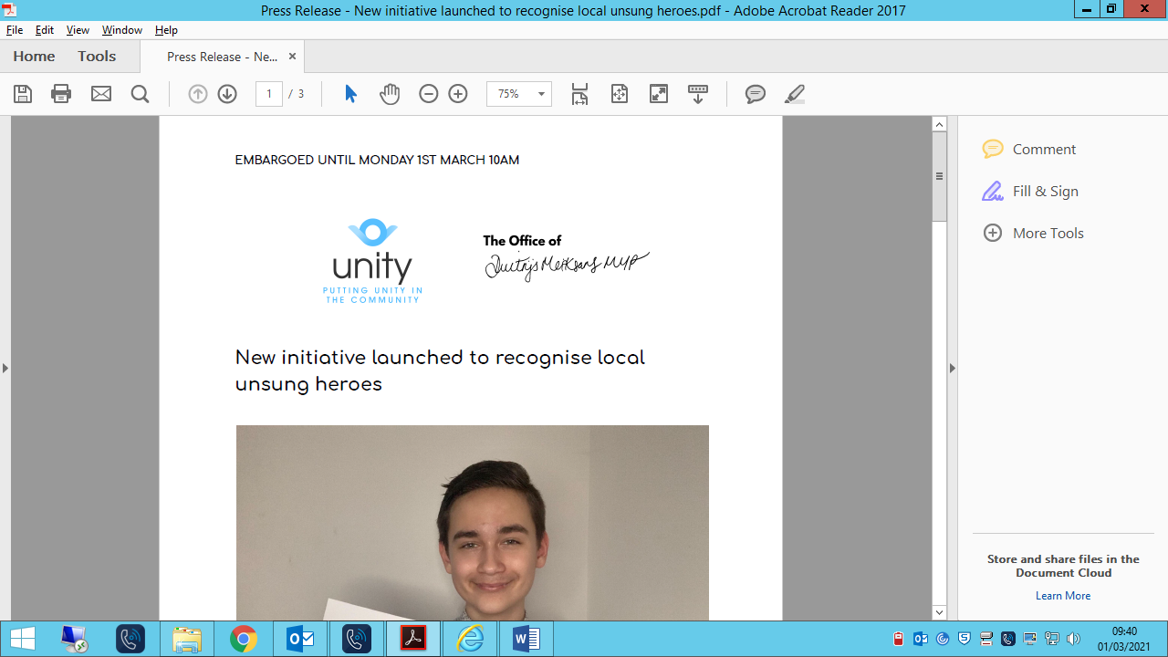
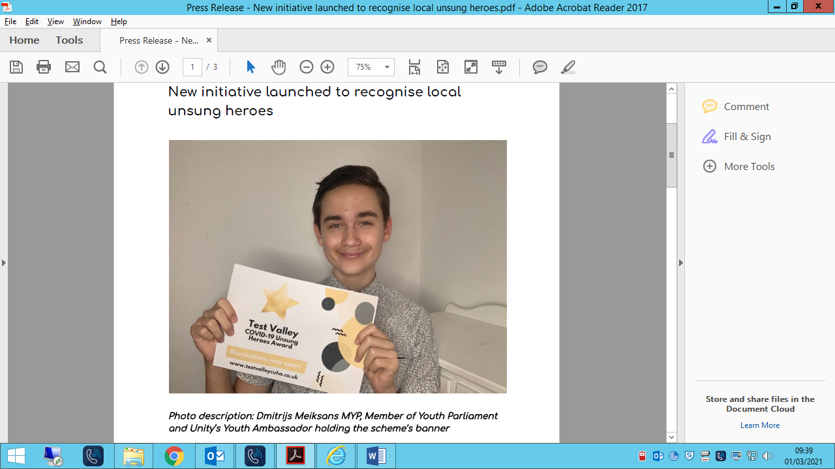

Dmitrijs Meiksans Member of Youth Parliament and Unity’s Youth ambassador in collaboration with Unity, has announced a new local awards scheme to recognise and highlight Test Valley’s Coronavirus heroes
Supported by Andover Town Council, Romsey Town Council, The Lifestyle Card, Love Andover and Test Valley Borough Council, the ‘Test Valley COVID-19 Unsung Heroes Award’ will run for ten weeks, starting from the 1st March, to recognise two unsung heroes weekly which will be shortlisted from a pool of nominations that will be received by members of the public.
“The pandemic has been difficult in so many ways and for a lot of people,” said Dmitrijs, “At the very beginning of the first lockdown, there began an urgent need for volunteers to support those shielding, vulnerable and self-isolating - and Unity pioneered to lead the Test Valley effort to support its residents during the pandemic via the Test Valley Community Helpline, with the support of local community organisations and Test Valley Borough Council.”
A call for volunteers saw a great engagement at the beginning of the pandemic, with local groups being created, such as the Andover Self-Isolation Group, and hundreds of volunteers stepping up to support their fellow residents by collecting medication and prescriptions, assisting with shopping and running errands.
“It is time now to further reflect on the selfless actions of the people who have dedicated a lot of time and effort to be able to provide for their local communities, and we wanted to do come together to do something to honour them and boost morale by sharing their stories of volunteering during the Coronavirus pandemic.”
Each recipient’s story will be shared on social media, via Andover Radio and the Love Andover platform, local newspapers, the blog on the official Test Valley COVID-19 Unsung Heroes Award website as well as other platforms.
“Unity has been engaged with the Covid-19 response since the pandemic commenced in March last year. To be able to sing the praises of those across the valley who have done so much to help their communities seems a natural extension to this work. Unity has been running the Test Valley Annual Volunteering Awards for many years, so it seems only right for us to be involved in this campaign. There are so many individuals who are deserving but to be able to shine the light on a few is extremely special indeed.” said Terry Bishop, Chief Executive Officer of Unity.
Members of the public are able to nominate their unsung hero by visiting www.testvalleycuha.co.uk/nominate.

Grants kick start community projects
Applications for Councillor Grants have been coming in thick and fast and we have now got more than enough applications for this financial year. The grants are limited to 2/3 of a project up to a maximum of £1000 but can have a big impact.
King’s Somborne Village Hall Have received a grant of £642 to develop a new easy to use web site that will improve marketing, on-line booking and payment. This builds on the huge TVBC support and investment made in the hall over recent years.
The King’s Somborne Primary School received a grant of £1000 to develop their Eco garden which is used not only by the school itself but the Preschool and others.
We are currently assessing other grants for this tranche but the scheme will be running again next financial year.

Nitrate Neutrality

Nutrient overload creates vast mats of algae over the Solent’s mudflats, stopping oxygen getting through to the animals in the sediment and causing mass mortality, especially in hot weather. Algae also forms a barrier to many birds which rely on probing the mud or picking off tiny invertebrates from its surface. Lastly, these mats can smother some of our most special yet threatened habitats: seagrass beds and saltmarshes, choking them to death and risking erosion.
Whilst nitrate pollution arises from a number of sources, including in particular agricultural run-off and outfalls, new occupied dwellings would add to the pressures through the waste water generated.
In an attempt to reduce the impact of new developments regulations now mean permission cannot be granted unless a development is nitrate neutral. Any additional nitrate resulting from development in the Solent fluvial catchment area has to either be removed or offset in some way. This has for some time now put the brakes on planning permissions affecting over 90 applications and 500 plus homes in Test Valley alone.
To unlock this situation Test Valley Borough Council is actively seeking to buy agricultural land that is currently adding nitrates. This can then be taken out of agricultural use and converted to a nature reserve/woodland for the benefit of the Test Valley residents. Then for a fee developer can use portions of this land to offset the nitrates caused by their own developments.
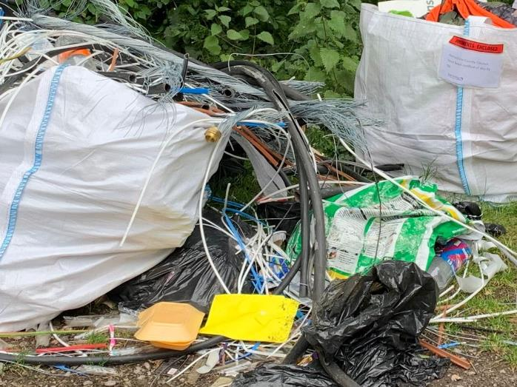

Further court success!
Two sisters have been ordered to pay more than £1,500 by the courts after failing to explain how their waste ended up fly-tipped in two car parks.
An investigation was launched by Test Valley Borough Council officers after waste was dumped at the Stoneymarsh car park along the A3057 last year.
Another load of waste was also discovered at Cowdown Lane near Andover.
The authority’s environmental service began looking in to the fly-tips and discovered the rubbish, full of cables and pipes and other waste.
After sending them both a formal request to attend interview, neither responded, which resulted in a day at Southampton Magistrates Court earlier this year.
They were fined £1,100, ordered to pay £286 compensation to TVBC for the clean-up costs, and a further £110 victim surcharge for failing to respond to a request for interview regarding the Stoneymarsh fly-tip.
In another separate success for the environmental service team, a Romsey man has been made to pay more than £1,000 after dealing scrap metal without the correct licences.
The man, of no fixed address, had been driving his truck around the area between January and April last year, and was collecting and disposing of scrap metal. However, when officers from Test Valley Borough Council asked him to produce his licences, no response was ever given.
He was fined £300, ordered to pay a £34 victim surcharge, and costs of £1,123, bringing the total financial costs to £1,457.


Review of the Strategic Housing and Economic Land Availability Assessment (SHELAA)
In accordance with government requirements, local planning authorities must undertake a SHELAA to identify potential sites and assess whether such sites are deliverable or developable for housing, employment or other economic uses.
As part of the next local plan preparations, a review of the SHELAA is due to commence in the coming weeks in order to provide an update on the availability and achievability of promoted sites for now and in the future.
The following information will be recorded:
• Whether any sites have been completed, are under construction or are no longer being promoted by the landowner.
• Whether any sites are the subject of planning applications or permissions.
• Progress which has been made on addressing constraints to development and the achievability of sites.
• The identification of any new constraints.
• Whether any previously unidentified sites have come forward that were not included in the SHELAA, but meet the minimum site size threshold (i.e. 5 dwellings / 0.15ha or 0.25 hectares (500m2) for employment land).
At this early stage of the review, those promoting land already within the SHELAA are being asked to confirm whether they wish to continue to do so and clarify, or update their details. A call for new site will follow in due course.
The SHELAA will only identify sites which have been promoted to the council; it does not allocate sites. The inclusion of the site in the SHELAA does not imply that the council would necessarily grant planning permission.

New extra care homes to open this summer

New homes for older people in Romsey are nearing completion following a partnership between Hampshire County Council (HCC), Test Valley Borough Council (TVBC) and Places for People.
Nightingale Lodge, based on the corner of Winchester Road and Cupernham Lane, is due to open this summer and offers extra care accommodation and 24-hour care and support on site. The development is aimed at people who have either existing care or support needs, or who anticipate needing support in the near future.
Thirty-seven of the apartments will be made available for affordable rent and 17 will be made available for purchase through a shared ownership scheme.
Now, those interested in the affordable rented apartments can make enquiries to Test Valley Borough Council (01264 368000), or find more information about extra care housing on the TVBC website. Applications should be made via Hampshire Home Choice – www.hampshirehomechoice.org.uk
Interested parties for the shared ownership apartments can also reserve the homes for sale at the development, by contacting Living Plus (part of Places for People) via: https://www.livingplus.co.uk/find-a-home/nightingale-lodge/
Extra Care housing provides an ideal solution for those who wish to remain living independently but need some form of care and support which can be tailored to suit their needs, and this development will ensure that residents in the south of the borough are able to have that choice made available to them.
In addition to the apartments, Nightingale Lodge offers a variety of facilities for use by both residents as well as the local community. These include a wellness suite, hair and beauty salon, a restaurant and landscaped gardens.

Our Contact Details
Councillor Ian Jeffrey cllrijeffrey@testvalley.gov.uk 01794 388872
Councillor Alison Johnston cllrajohnston@testvalley.gov.uk 01794 500610
Councillor Tony Ward cllrtward@testvalley.gov.uk 01794 389649

