Mid-Test Matters
Issue 23 30 April 2021
A newsletter for Parish Councillors and Community Volunteers
TVBC Supporting communities during 12 months of Covid
£440k | Provided £440,000 of council tax support to more than 2,000 households
2,705,424 | Collected 56,363 bins per week - that’s 2,705,424 bins since lockdown began in March
£56m | Paid out £56m of grants and rate relief to support over 3,200 local businesses
181 days | We suspended parking charges for 181 days to support people picking up supplies
£23k | Provided £23,124 to 54 community groups to help  them deliver food supplies and prescriptions to residents
1,966 | Worked with 1,966 volunteers providing vital support to their local communities
79,075 | We responded to almost 80,000 customer enquiries
3,003 | Answered 3,003 calls to the Test Valley Community Helpline
440 | 440 households helped into housing

Vaccines and the lock down are working
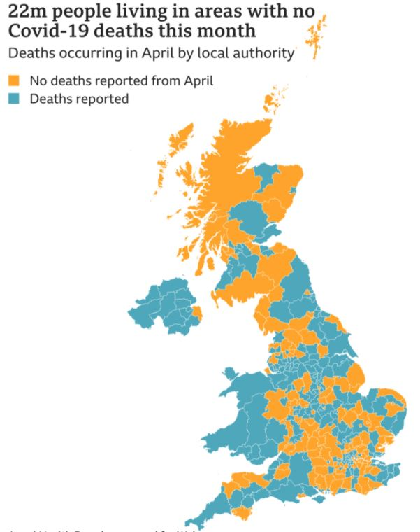
BBC research has shown that thankfully the deadly cost of Covid-19 is diminishing. Although difficult to see on the map Test Valley is one area where no deaths due to covid-19 were reported in April. The Government and all the evidence from other parts of the world is that even with vaccines we need to continue to be cautious –Hands, Face, Space and Fresh Air

COVID-19 - Community Testing update
The Government announced on Monday that free rapid coronavirus testing will be available to everyone in England from 9 April (today). People without symptoms are being encouraged to take regular twice weekly tests to help prevent outbreaks and help us reclaim a more normal way of life.
Here is a video clip of our Picket Twenty testing centre for people without symptoms: https://youtu.be/KuxYWlAfFlg.
You can book a test to be carried out at site online here: https://outlook.office365.com/owa/calendar/TestValleyAsymptomaticTestCentre@hants.onmicrosoft.com/bookings/
Picket Twenty is also a home test collection point and from today collections will open up to everyone.
Opening hours are:
Mon, Wed, Fri: 7.30am – 2.30pm*
Tues & Thurs: 12 noon – 6.30pm*
Saturdays: 9am – 1.00pm*
Sundays and Bank Holidays: Closed
*Last entry for testing is 30 mins before the stated site closure time

COVID-19 mental health and wellbeing recovery action plan

The government has published its COVID-19 mental health and wellbeing recovery plan which sets out an ambitious, cross-government, whole-person approach to promoting positive mental health and supporting people living with mental illness to recover and live well.
While this plan sets out what government will do in the coming year, it is also a call to action for the whole of society, for local communities, families and for individuals, who can take simple steps to look after their own wellbeing and the wellbeing of those around them – and can reach out for support, including from mental health services when necessary.
Plan: https://www.gov.uk/government/publications/covid-19-mental-health-and-wellbeing-recovery-action-plan

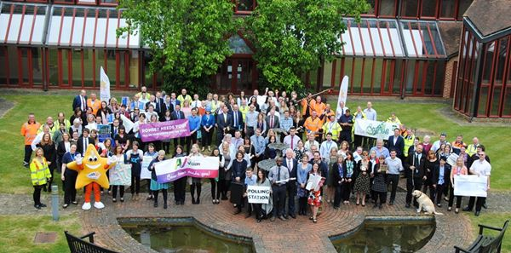
Kickstart your career at Test Valley Borough Council!

Test Valley Borough Council has a range of fantastic new roles up for grabs as part of the government’s Kickstart Scheme.
The initiative aims to help young people who are at risk of long-term unemployment due to the coronavirus pandemic and is available to 16 to 24-year-olds on Universal Credit.
The posts are 25 hours per week for six months and include business support assistant, admin assistant, HR admin assistant and housing assistant. Anyone interested should speak to their Job Centre work coach who will then refer them to the council.
Update on Leisure Centre re-opening
From the 29 March we saw the re-opening of Charlton Pavilion and golf courses, along with the re-opening of Knightwood Leisure Centre outdoor courts and pitches and café for takeaway only.
The 12 April will see the more comprehensive re-opening of our Leisure Centres, with bookings for gym and lane swimming sessions already available.
Indoor badminton can take place from the 12 April, but only in same household bubbles. 1 to 1 coaching and junior coaching can take place, within the England Badminton guidelines.
Studio classes are due to resume pending the government guidelines for the next step out of lockdown in mid-May, access to Virtual classes to do at home will be available for free through the Places Locker App until they resume.
Children’s swimming lessons will resume on 12 April in Andover and 19 April in Romsey.
Children’s gymnastics sessions in Andover will resume on 19 April.
Andover Clip and Climb is due to re-open on 14 April. It will be open to book sessions on Wednesday and Friday next week as it is the school holidays, then will be open at weekends initially.
For more details on what is open at the Test Valley sites keep an eye on this page https://www.placesleisure.org/coronavirus/test-valley/
For the latest membership deals which is currently first month free, check out the local centres webpages.
Role of Borough Councillors and Planning
During the last 12 months there have been 490 planning applications in the Mid Test Ward. Many were relatively straight forward but some required considerable effort on our part answering residents’ questions, providing advice on the planning process, site visits, sometimes acting as an interface with the Planning Officers and of course the planning meetings themselves. An example requiring all those facets came to a conclusion this week when an application to build 18 houses on the Kings Somborne Allotments was refused by the Committee.
In order to best serve the very large Mid Test Ward we have allocated different areas to cover. Cllr Alison Johnston covers Mottisfont, Broughton, Houghton and Lockerley parishes and attends their Parish Council meetings, Cllr Ian Jeffrey covers the parishes of West Tytherley, East Tytherley, East Dean, Over Wallop and Nether Wallop attending their meetings and Cllr Tony Ward covers King’s Somborne, Stockbridge and Longstock.
The Southern Area Planning Committee has just 13 Members and Cllr Johnston and I are Members of that committee. Cllr Jeffrey can act as advocate at a Planning meeting if he, Cllr Johnston, I or a Parish Council think it’s useful.
Where the public and/or a Parish Council want to reinforce objections or support for a particular application they can and do call or email us before a Planning Committee meeting.

Committee meetings from 7 May 2021
Following a judgment delivered in the remote meetings High Court case those Zoom and Teams meetings are coming to an end. Remote meetings CANNOT continue after 6 May 2021. The Court found that the existing provisions under the 1972 Act require meetings to take place at a single, specified geographical location and being ‘present’ at that location involves a physical presence at that location.
Given this outcome, the Council’s committees will return to physical meetings from 7 May. Social distancing is still in place until 21 June 2021 and therefore there will be a need for committee meetings to operate in a slightly different way than normal during this period. A Covid Risk Assessment has been undertaken to ensure that meetings can take place in a secure way.
Supporting Communities with Grants

During the last 12 months we were able to help a number of community projects with grants.

  - Test Valley School - £1000 for improvements to the animal area

  - Stockbridge Town Hall - £6250 for theatre curtains

  - King’s Somborne School - £1000 for eco garden

  - Houghton Parish Council - £1000 for speed indicator

  - King’s Somborne Village Hall - £642 for web site

  - Nether Wallop PC - £1000 - NDP support

  - Wallop Pre-School - £1000 – Tapestry project

  - Longstock Allotments - £800 – Community garden

  - King’s Somborne PC - £1000 – Preschool canopy

  - King’s Somborne Village Hall - £22,167 for audio/visual system

Cllrs Alison Johnston, Ian Jeffrey and Tony Ward

